Welcome to jPDFEditor v2022R1 – Java PDF Editor / Redaction Tool

End User Guide for integrated PDF editor and redaction tool in applications or websites.
This guide serves as a reference tool for end users using jPDFEditor deployed in a Java or a Java webstart application.
Note: Some features and functionality within this guide may not be available depending on what has been enabled/disabled in your distribution. Contact your application administrator for additional details.

Main Features
- Open and display PDF files (and image files)
- Print PDF files
- Convert text and image files (gif, png, jpg, tiff) to PDF on the fly
- Fill and save interactive PDF forms (Acroforms, XFA non-dynamic)
- Review and Markup PDFs (all PDF annotations and text markups supported)

  - Text annotations: sticky note, typewriter, text box
  - Text markups: highlights, cross-out, underline
  - Caret annotations: delete, replace, insert
  - Other annotations: sound, rubber stamps, image annotations
- Content Editing: the content editing tool allows users to modify content in PDF documents:

  - Copy, delete, edit, move text
  - Copy, delete, move, resize images
  - Copy, delete, edit, move, resize shapes and paths
  - Work with single or multiple text, image, or path objects
- Redaction: the redaction feature lets users permanently remove sensitive information from PDF documents:

  - Add redaction annotations to cover an area on a page. The area can contain any PDF objects such as text, image, or shape objects.
  - “Burn” the redaction annotations to remove the underlying content that intersects with the area redacted.
- Digitally sign PDF files (and validate existing signatures)
- Text search, selection, copy
- Easy navigation with thumbnail, bookmark, annotation, signature views
- Advanced display tools: zoom, loupe, snapshot, pan and zoom
- Full support for the following:

  - The latest PDF formats
  - All image types: PNG, TIFF, JPEG, JBIG2 and JPEG 2000
  - All font types
  - All color spaces
  - File attachments
- Scan-to-PDF to create documents from scan (optional module)
- OCR PDF documents (optional module)
- Available in English, French, German, Italian and Spanish
- Works on Windows, Mac OS X, Linux and Unix (100% Java)

Downloadable User Guides
The following user print versions of the user guides are available for download.

Word
jPDFEditor User Guide (.docx)

PDF
jPDFEditor User Guide (.pdf)
To start using jPDF Editor, simply launch and open a PDF document using the Open button on the toolbar. Once a document is loaded, you can print, save, or navigate through the document at any time using the toolbar.

The Toolbar
The Toolbar is located at the top of the jPDF Editor window. The toolbar is where you will find all of the most commonly used functions in jPDF Editor.

Panes
Panes are where you will find additional tools or information on the current document. These panes can be resized by clicking and dragging the edge of the pane. Pane can also be completed closed by either clicking the "x" on the top right of the pane, using the toggle buttons on the left of the jPDF Editor window.
Details of each of the panels are listed below.

Left Pane
The left pane can show one of four different views. The views can be toggled by their respective buttons on the left side of the screen. The following views are available:
- Pages Pane – view miniature versions of all the pages in the documents. Click a thumbnail to go to that page. Thumbnails can be dragged and dropped within a document to move pages, or across documents to copy pages into another document. You can also drag supported file types to the thumbnail pane to add them as PDF Pages.
- Bookmarks Pane – view bookmarks or the document's table of contents, if present. Bookmarks allow navigation through bookmarked regions.
- Destinations Pane - view PDF destinations
- Attachments Pane - view files that have been attached to the PDF document, if any. Attached files can be viewed, saved, or deleted.
- Layers Pane – view layers contained in the document, if any. You can toggle layers by checking them on or off.
- Signatures Pane – view digital signatures that have been applied to the document.

Bottom Pane
The Comments view in the bottom pane shows any comments / annotations in the document. Navigate to a specific comment by selecting it in the list.

jPDFEditor Toolbar
The toolbar is located at the top of the jPDF Editor window. The toolbar is where you will find all of the most commonly used functions in jPDF Editor.
The default toolbar is setup as displayed above but can vary depending on your application setup.

Toolbar Descriptions

File
Open: Open a PDF document or convert any of the supported file types to a PDF.
Save: Save the current document.
Print: Print the current document.

Navigation
First Page: Navigates to the first page of the document.
Previous Page: Navigates to the previous page in the document.
Page Number: Displays the current page being viewed and the total number of pages. Type a number into the field and press "Enter" to navigate directly to that page.
Next Page: Navigates to the next page in the document.
Last Page: Navigates to the Last page in the document.
Previous View: Navigates to the last view within the document.
Next View: Navigates to the next view within the document.

Page Fit
Actual Size: Displays the document with a 1:1 ratio to match how the document would look if printed without any scaling.
Fit to Width: Scales the view to fit the width of the document in the jPDF Editor frame.
Fit to Page: Scales the view to fit the entire document within the jPDF Editor frame.

View Rotation
Rotate View Clockwise: Rotates only the view within the document clockwise (Note: This rotation will NOT be saved when the document is saved then reopened).
Rotate View Counter Clockwise: Rotates only the view within the document counter clockwise (Note: This rotation will NOT be saved when the document is saved then reopened).

Zoom
Zoom Out: Zoom out to view the content smaller.
Zoom To/Current Zoom: Displays the current zoom value. You can also select a preset zoom percentage or type in the field for a custom zoom value.
Zoom In: Zoom in to view the content larger.
Zoom Tool: Zooms to a selected area within a page. Click and drag to select the rectangle area you wish to zoom to.
Loupe Tool: Displays a zoom window that zooms in on the PDF to show the smallest detail.
Pan and Zoom: A window showing the portion of the page currently on screen. Drag the red box to adjust the view of the document.

Document
Edit Content: Allows you to edit content within the PDF.
Mark for Redaction: Marks content for redaction.
Sign Document: Allows you to digitally sign the current PDF.

Standard
Drag and Scroll Page: Click and drag to scroll or move the pages.
Select Text: Click and drag to select text within the document.
Edit Interactive Objects: Used to edit interactive objects within the PDF which include annotations, signatures, and links.
Take Snapshot: Used to save a portion of the screen as an image.
Search Text: Used to search the text of a PDF document.

Text Comments
Sticky Note: Creates a sticky note annotation.
Typewriter: Creates a typewriter annotation.
Text Box: Creates a text box annotation.
Callout: Creates a callout annotation.

Shape Comments
Circle: Creates a circle annotation.
Arrow: Creates an arrow annotation.
Line: Creates a line annotation.
Square: Creates a square annotation.
Pencil: Creates a pencil annotation.
Polygon: Creates a polygon annotation.
Cloud: Creates a cloud annotation.
Polyline: Creates a polyline annotation.

Text Markups
Highlight Text: Used to highlight text on a document.
Crossout Text: Used to cross out text on a document.
Underline Text: Used to underline text on a document.
Squiggly Underline Text: Used to squiggly underline text on a document.
Insert Text: Adds an insert text markup on the document.
Replace Text: Adds a replace text markup on the selected text.
Area Highlight: Highlights an area on a document. Useful when trying to highlight scanned text.

Rubber Stamps
Rubber Stamp: Used to place a rubber stamp on the document.

Multimedia
Sound: Adds a sound annotation attachment to the document.
Image: Adds an image as a rubber stamp annotation to the document.
Link: Used to create links in a document.
Attach File: Attaches a file to the PDF without an annotation.
Attach File as Comment: Attaches a file to the annotation with an annotation.

Measurements
Distance: Used to measure the distance between two points on the document.
Perimeter: Used to measure the perimeter on the document using multiple lines.
Area: Used to measure a designated area on the document.

Properties - Appearance
Fill Color: Allows you to select the fill color of the selected objects.
Border Color: Allows you to select the border color for the selected objects.
Line Width: Sets the border line width for the selected objects.
Transparency: Sets the transparency for the selected objects.

Properties - Text
Font: Sets the font for the selected annotation.
Size: Sets the font size for the selected annotation.
Text Color: Sets the font color for the selected annotation.
Bold: Makes the selected annotation text Bold.
Italic: Makes the selected annotation text Italic.
Underline: Makes the selected annotation or text underlined
Strikethrough: Marks the selected annotation or text with a strikethrough
Horizontal Alignment: Sets the text alignment for the selected annotation.

Others
Divider: separates each of the toolbar sections.
Options: used to choose between different options for the tool it is attached to.

Mini Toolbar
The mini toolbar is a small toolbar that is displayed when an Annotation or Link is selected. This toolbar allows you to easily access the properties or delete the selected object without needing to use the right click context menu or keyboard. The toolbar can be enabled or disabled in the Toolbar Preferences.
Note: The mini toolbar will only be displayed on form fields when Selecting Objects.
The Mini Toolbar has the following buttons
Fill Color: Allows you to select the fill color of the selected objects.
Border Color: Allows you to select the border color for the selected objects.
Text Color: Sets the font color for the selected annotation.
Properties: Opens the properties for the selected annotation or link
Delete: Deletes the selected annotation or link

Quick Properties Toolbar
The quick properties toolbar allows you to edit the selected object's properties without having to access the object's properties dialog. The quick properties toolbar options will enable and disable based on the available options of the selected objects. More than one object's properties can be edited at the same time as well.

Using the Quick Properties Toolbar
- Using the Hand Tool or Object Selection Tool select the object (annotations, markups, or form fields) that you wish to edit
  - Note:More than one object can be selected at a time
- Use the buttons on the toolbar to quickly edit any of the available properties that you wish to change
  - Note:The quick properties toolbar options will enable and disable based on the available options of the selected objects.

Quick Properties Options

Properties - Appearance
Fill Color: Allows you to select the fill color of the selected objects.
Border Color: Allows you to select the border color for the selected objects.
Line Width: Sets the border line width for the selected objects.
Transparency: Sets the transparency for the selected objects.

Properties - Text
Font: Sets the font for the selected annotation.
Size: Sets the font size for the selected annotation.
Text Color: Sets the font color for the selected annotation.
Bold: Makes the selected annotation text Bold.
Italic: Makes the selected annotation text Italic.
Underline: Makes the selected annotation or text underlined
Strikethrough: Marks the selected annotation or text with a strikethrough
Horizontal Alignment: Sets the text alignment for the selected annotation.

Selecting Text
Click on the Select text icon on the toolbar, then drag the mouse to select the desired objects. When right-clicking on the mouse (Mac: Ctrl + Click), a menu will appear giving you the choice to copy the text to the clipboard; highlight, underline, cross out, squiggly underline, or replace the selected text; or insert new text after the selection.
Note: When copying text it will preserve Font, Color, Size, Bold & Italic properties of the selected text.
To exit the selection mode, simply click on the hand tool or Esc on the keyboard.

Rectangular Text Selection
For rectangular text selection, hold down Ctrl (Command for OSX) while dragging the mouse. The cursor will change to to indicate that a different selection mode is active.
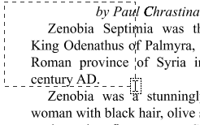

Text Selection Options
Copy to Clipboard - copies the selected text to the OS clipboard
Paste - pastes the content currently stored in the OS clipboard into the document
- Text: will be pasted as a Text Box Comment
- Image: will be pasted as an image stamp
- File Data: will be pasted as an attachment

Markup Tools
Highlight Text - highlights the selected text
Underline Text - underlines the selected text
Cross Out Text - adds cross out to selected text
Replace Text - adds replace text markup to selected text
Mark for Redaction - add redaction annotation to selected text

Selecting Objects
The object selection tool can be used to edit objects that are not a part of the actual PDF content. Below is a list of the objects that can be selected.
- Annotations
- Text Markups
- Form Fields
- Links
- File Attachment Comments
- 3D content

Using the Object Selection Tool
Click on the Object Selection icon on the toolbar, then click or drag an area with the mouse to select the desired objects. Once selected objects can be edited, moved, or deleted just the same as you would anything else.
To exit the selection mode, simply click on the hand tool or Esc on the keyboard.

Snapshot Tool
The snapshot tool can be used to save a portion of the screen as an image.
Select the snapshot tool icon from the toolbar then drag the mouse over the page to select the snapshot area.
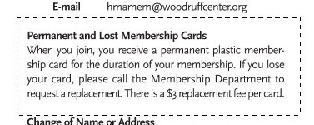
When the mouse button is released, an image will be created from the selected area. The image is copied to the system clipboard.

Quick Search
With jPDFEditor v2022R1, you can quickly search for text within a PDF document. The quick search tool allows you to search for just the next occurrence of the text within the document. To find a list of all occurrences within the document use the Advanced Search instead.
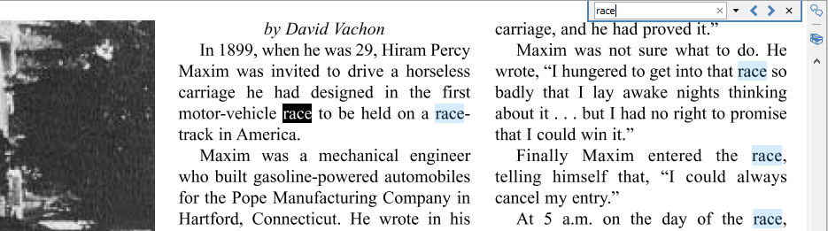

How to use Quick Search
- Open the document that you wish to search
- Open the quick search popup by going to Edit > Search or using the shortcut key Ctrl + F (Command + F on Mac)
- Enter the text you wish to search for and press the "Enter" key to find the next occurrence of the text within the document

Quick Search Options
Previous Occurrence: Navigates to the previous occurrence of the word in the document
Next Occurrence: Navigates to the next occurrence of the word in the document
Note: Pressing the "Enter" key will also continue to the next occurrence
Search Options: Used to set the quick search options. Click on the arrow to select the options you wish to use

  - Advanced Search: This will open the Advanced Search and begin searching for the text currently in the search field.
  - Case-Sensitive: If checked, searching for the string "The" will not return the same results as searching for the string "the".
  - Whole words only: If checked, searching for "the" will not return occurrences of "they". But when this option is left unchecked, all occurrences of "they", and other words with the letters "the", will appear in the occurrence list.
  - Include comments: If checked, the search will include text in annotation comments.
  - Include fields: If checked, the search will include text in form fields. (this is on by default)

Text Search
The Advanced Text Search tool in jPDFEditor allows you to see a complete list of all the results. This tool allows you to see the results of the search in context with the text around the result to help locate the section of the document with the correct text.
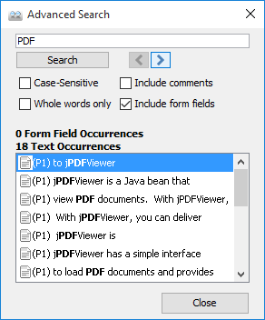

How to use Advanced Search
- Open the document that you wish to search
- Click on the Text Search button on the toolbar, press Ctrl + Shift + F (Cmd + Shift + F on Mac)
- Enter the text to search for in the text field, and press the Enter key or click on the Search button. All occurrences of the text in the document will appear in the occurrences list.

To navigate through the results:
- Use the Up arrow key (previous) and Down arrow key (next).
- Click on the Previous Occurrence or Next Occurrence buttons next to the New Search button.
- Use the F3 (next) and Shift + F3 (previous) keys.
- Click on the result with the mouse

Advanced Search Options
Previous Occurrence: Navigates to the previous occurrence of the word in the document
Next Occurrence: Navigates to the next occurrence of the word in the document
Note: Pressing the "Enter" key will also continue to the next occurrence
Case-Sensitive: If checked, searching for the string "The" will not return the same results as searching for the string "the".
Whole words only: If checked, searching for "the" will not return occurrences of "they". But when this option is left unchecked, all occurrences of "they" will appear in the occurrence list.
Include comments: If checked, the search will include text in annotation comments.
Include fields: If checked, the search will include text in form fields. (this is on by default)

Printing PDFs
PDF documents can be printed from within jPDF Editor. To print a document just click on the Print button on the toolbar.
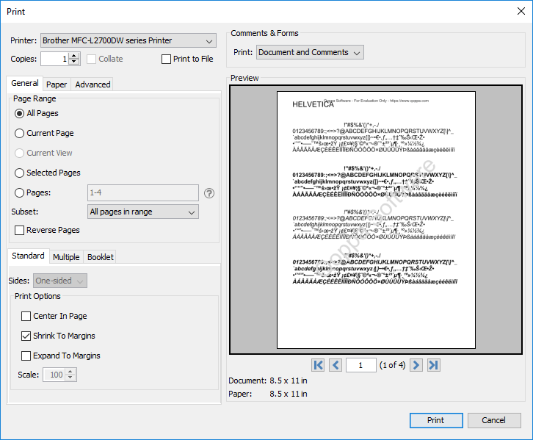

Print Options
The below print options are available when using the jPDF Editor Print dialog. Settings options will be enabled and disabled based on what the printer tells jPDF Editor is available.
Note: There may be some cases where the printer may support an option that is listed as disabled because it was not reported as available to jPDFEditor.
Printer - The name of the printer you wish to print to
Copies - The number of copies of the document to be printed
Collate: Keeps pages in order when printing multiple copies. For example, if unchecked, two copies of a three-page document will print in this order: 1,1,2,2,3,3. If checked, the order will be 1,2,3,1,2,3. This option is not available when printing only one copy.
Print to File - Option to print to a .prn file instead of directly to the printer. This allows you to reprint the document without running or even having the original application that created the file. For example, if you need to send the document to a printing company that only prints on a specific printer.

General

Page Range
All Pages: all pages in the document
Current Page: the current page being displayed
Current View: prints the page exactly as it is displayed in the current PDF jPDFEditor frame. Note: This option will be disabled if more than one page is currently being displayed.
Selected Pages: prints the pages currently selected in the thumbnails pane
Pages: set custom range of pages if needed using values separated by commas. For example, to print only pages 2 to 4 & 6 to 12 & 20 of a 30 page document enter “2-4, 6-12, 20″.
Subset: Subset of the currently set page range to print. Choose from the below options
- All pages in range: prints all the pages in the set range
- Even pages only: prints only the even pages in the set range (i.e. 2, 4, 6, etc...)
- Odd pages only: prints only the odd pages in the set range (i.e. 1, 3, 5, etc...)
Reverse Pages: reverse the order in which the pages will come out of the printer

Standard Printing
Sides - The options to print pages either one sided or on both sides of the paper
- One-sided: prints only one page on the front of each sheet of paper
- Two-Sided (short edge): prints two pages, one on front and one on back, per sheet of paper flipping the page on the short edge
- Two-Sided (long edge): prints two pages, one on front and one on back, per sheet of paper flipping the page on the long edge
Print Options - Additional print options to size the content to the page.
- Center In Page: center the page in the paper. No effect if the pages in a document are larger than the paper they are being printed on.
- Shrink To Margins: shrink pages so that they fit in the paper. No effect if the pages in a document are smaller than the paper they are being printed on.
- Expand To Margins: expand pages to fill the paper they are being printed on. No effect if the pages in a document are larger than the paper they are being printed on.
- Scale: Sets a custom scale to the document when printing. This option is only available when Shrink to Margins or Expand to Margins are not selected.

Multiple Pages per Sheet Printing
Pages per sheet: Number of pages from the document that should be printed per sheet. Pages will be added to the sheet using evenly spaced grids
Page order: Options to order the pages Horizontally from top to bottom or Vertically from left to right
Page margins: Adjusts the spacing between each of the page grids
Sides - The options to print pages either one sided or on both sides of the paper
- One-sided: prints only one page on the front of each sheet of paper
- Two-Sided (short edge): prints two pages, one on front and one on back, per sheet of paper flipping the page on the short edge
- Two-Sided (long edge): prints two pages, one on front and one on back, per sheet of paper flipping the page on the long edge
Auto-rotate individual pages in sheet: Rotates each individual page so that the width and length best fit each of the individual grids on the sheet.
Print border: When checked adds a border around each of the pages on the sheet

Booklet Printing
Booklet subset: Subset of the currently set page range options. Choose from the below options
- Both Sides (long edge): This will print all of the booklet pages on both sides of each sheet of paper so that when folded will create a booklet.
- Front sides only: Will work just as it currently does only printing the front sides of the booklet so the user can flip the pages and print the back sides to manually duplex if needed.
- Back sides only: Will work just as it currently does only printing the back sides of the booklet
Page margins: Adjusts the spacing between each of the page grids
Binding: Determines whether the binding (folded edge) of the booklet when folded should be on the left or the right
Auto-rotate individual pages in sheet: Rotates each individual page so that the width and length best fit each of the individual grids on the sheet.
Print border: When checked adds a border around each of the pages on the sheet

Paper
Paper Size - The size of the paper to be printed on. This sizes in the list are determined by the printer that is selected
Paper Tray - The tray on the printer where the paper will be coming from
Orientation - The layout and direction of the content being placed on the page
- Auto Rotate pages: rotate the printout to match the width and length with the paper. The portrait / landscape settings cannot be set by the user when this option is selected.
- Portrait: print the page portrait
- Landscape: print the page landscape
- Reverse Landscape: print the page landscape but reversed

Advanced
Chromaticity - Sets the color of the document to be printed
- Monochrome: will print in B&W or grayscale
- Color: will print the document in color
Quality - Sets the quality of the pages to be printed
- Draft: fast printing a low quality
- Normal: normal print quality at standard speed. Best for most printing situations
- High: high quality print for fine details. May take much longer to print

Performance - Sets additional advanced options to improve printing performance
- Print as image - instead of sending drawing commands to the printer sends single image per page. Useful when running into performance issues on documents with very large amounts of drawing commands on the page
- Scale image to output - tells the printer to rescale images to match output DPI, setting it to false sends the image in its original size and lets the printer resize it.

Comments & Forms
Print: Sets the printing options for documents with comments and forms
- Document and Comments: prints the document with all comments
- Document Only: prints the document without any comments. For a list of all comments that will be removed see Annotating and Commenting PDFs
- Form Fields Only: prints only the form fields and no other content.
Note: Form fields are always printed with each of the above settings

Preview
The print preview panel displays what the document will look like once printed based on the selected options, as well as contain navigation buttons allowing you to navigate the preview pages, and document properties showing selected paper and document sizes. Changing printing options will update the preview in real time.
Note: On Mac OS and Linux, some printers will always display "Color" even if the printer only prints in black & white.
First Page: Navigates to the first page of the preview document.
Previous Page: Navigates to the previous page in the preview document.
Page Number: Displays the current page being viewed and the total number of pages. Type a number into the field and press "Enter" to navigate directly to that page.
Next Page: Navigates to the next page in the preview document.
Last Page: Navigates to the Last page in the preview document.

Touch Mode
Touch mode can be enabled on your device by clicking on the Touch Mode icon on the toolbar or going to View on the menu bar then selecting Touch Mode.
Features added specifically for Touch Mode.
- Enlarged re-size handles on annotations and form fields for easier control
- Enlarged fonts and rows in comments and thumbnail panes.
- Mini toolbar during object selection for quick access to delete & show properties

Undo
In jPDFEditor, it is possible to undo most actions.
Undo or redo by using the standard shortcut keys:
Undo: CTRL + Z; Cmd + Z on Mac OSX
Redo: CTRL + Y; Shift + Cmd + Z on Mac OSX
Note: Shortcuts may be different depending on your applications's setup. See the specific documentation for your application for details.

Actions that can be undone / redone:

Annotations
(Textbox, callout, sticky note, typewriter, 8 shapes, sound, image, link, area highlight, measurements, stamp)
- Add

  - New
  - Paste
  - My Comments
  - Recent Comments
- Move

  - Mouse
- Keyboard
- Resize
- Change properties
- Flatten
- Delete
- Mark with Checkmark
- Review

Bookmarks
- Add
- Rename
- Delete
- Reorder

Content editing – text, path objects, image
- Redact (before being applied)
- Delete
- Move
- Edit text properties (text data, font, outline color, size, etc..).
- Edit path object properties
- Resize path and image

Form
- Edit field contents

Markup (highlight, crossout, underline, squiggly, replace, insert)
- Add
- Move
- Change properties
- Flatten
- Delete

Pages
- Rotate
- Crop
- Header/Footer/Watermark

Actions that reset the undo / redo stacks:

Document
- Save
- Security

  - Sign Field
  - Sign
  - Remove Signatures

Page
- Move
- Delete

Form
- Flatten form fields
- Reset form fields

Actions that are being ignored:

Document
- Attach file
- Add a blank page
- Insert pages

Import Annotations
jPDFEditor can convert non-PDF file types into PDF Documents. See Supported File Types for a list of the supported file types.
- Converting Images to PDF - Converts image files to PDF.
- Converting Text to PDF - Converts text files to PDF.

Converting Images to PDF
jPDFEditor can convert Images to PDF. The following image types can be converted *png, *jpg, *jpeg, *jpe, *gif, *tif & *tiff.

Instructions:
- Click on the Open button on the toolbar.
- Change the files filter to the image format you wish to convert (PNG, JPEG, GIF, or TIFF)
- Open the Image file you wish to convert
- Upon opening the file,jPDF Editorwill automatically convert the Image to a PDF document that you can then save as new PDF document.

Converting Text to PDF
jPDFEditor can convert text documents with a .txt extension to PDF.

Instructions:
- Click on the Open button on the toolbar.
- Change the files filter to Text Files (*txt)
- Open the text file you wish to convert
- Upon opening the file,jPDF Editorwill automatically convert the Text file to a PDF document that you can then save as new PDF document.

Supported File Types
jPDFEditor supports converting certain non-PDF file types into PDF Documents. The current supported types are:
- Image Files: *png, *jpg, *jpeg, *jpe, *gif, *tif & *tiff.
- Text Files: .txt
jPDFEditor provides extensive functionality for viewing and comparing PDFs.

Viewing PDFs
Navigating: General navigation tips and tools
Zooming: Zooming in/out of the document
Setting Page Layout: Setting how the pages are displayed
Rotating Page View: Rotating the view of the page
Loupe Tool: Magnify a small region of the page
Pan and Zoom Tool: Display a window with the current location on the document
Invert Colors Mode: Invert colors when displaying PDFs for accessibility
PDF Layers: enable, disable, create, and edit layers.

Comparing PDFs
Side by Side Comparison: Compare two different PDFs next to each other
Overlay Comparison: Compare two different PDFs on top of each other highlighting the differences

Navigating
jPDFEditor has a variety of methods that can be used to navigate PDF documents.

Using the Mouse
The primary method for navigating within PDF documents is with the mouse. jPDF Editor is compatible with all standard mice and supports the following actions using the 2 buttons and scroll wheel typically found on the mouse.
Note: On Mac if using a mouse with a single button you can right click by holding Ctrl and clicking the mouse button

Left Mouse Button
- Click to select items
- Hold down to drag items

Scroll Wheel
- Scroll the pages in the document

Right Mouse Button
- Displays context menus with additional options

Panning/Moving Pages
With the hand tool selected click and drag anywhere on the page to pan the document
Using the scroll wheel on the mouse you can move the document up and down
You can also use the vertical and horizontal scrollbars to pan the document by clicking and dragging on the scrollbar

Using the Keyboard
The keyboard can also be used in some cases to quickly navigate the document using shortcut keys. The following shortcuts can be used.
Action | Windows/UNIX | Mac
First Page | Home | Home
Last Page | End | End
Next Page | PgDn or Space | PgDn or Space
Previous Page | PgUp or Shift + Space | PgUp or Shift + Space
Go to Page | Ctrl + Shift + P | ⌘ + Shift + P
Scroll Down | Space or ↓ | Space or ↓
Scroll Up | ↑ | ↑
Next view | Alt + → | ⌘ + [
Previous view | Alt + ← | ⌘ + ]

Using the Navigation Tools
The navigation tools are located on the main toolbar and can be used to navigate the document.
First Page: Navigates to the first page of the document.
Previous Page: Navigates to the previous page in the document.
Page Number: Displays the current page being viewed and the total number of pages. Type a number into the field and press "Enter" to navigate directly to that page.
Next Page: Navigates to the next page in the document.
Last Page: Navigates to the Last page in the document.
Previous View: Navigates to the last view within the document.
Next View: Navigates to the next view within the document.

Using Page Thumbnails
The page thumbnails can be found on the left side of the window. If not displayed the pane can be opened using the Pages button on the left side of the screen
The page thumbnails show miniature versions of all the pages in the documents.
- Click a thumbnail to go directly to that page.
- use the Left ← and Right → arrow keys to navigate to the Previous and Next pages

Using Bookmarks
The bookmarks pane is located on the left of the window. If not displayed the pane can be opened using the Bookmarks button on the left side of the screen.
Using bookmarks can be useful when navigating large PDFs that contain many pages. Often bookmarks are put in place to label chapters or sections within a document. Click on the bookmark to jump directly to that location in the document.

Using Destinations
The Destination pane is located on the left of the PDF Studio window. If not displayed the pane can be opened using the Destinations button on the left side of the screen.
Using destinations can be useful when navigating large PDFs that contain many pages. Destinations are additional navigation tools put in place to label specific locations or sections within a document. Click on the destination name to jump directly to that location in the document.

Zooming
When viewing a document there are several ways to zoom in/out of the document.

Using the Mouse
To zoom in or out on the document using the mouse hold down Ctrl (Alt on Mac) and scroll the mouse wheel up to zoom in and down to zoom out.

Using the Keyboard
The keyboard can also be used in some cases to quickly zoom on the document using shortcut keys. The following shortcuts can be used.
Zoom to actual size | Ctrl + 1 | ⌘ + 1
Zoom to fit page | Ctrl + 0 | ⌘ + 0
Zoom to fit width | Ctrl + 2 | ⌘ + 2
Zoom in | Ctrl + Plus | Alt + Plus
Zoom out | Ctrl + Minus | Alt + Minus

Using the Zoom Tools
The zoom tools are located on the main toolbar and can be used to zoom on the document.
Zoom Out: Zoom out to view the content smaller.
Zoom To/Current Zoom: Displays the current zoom value. You can also select a preset zoom percentage or type in the field for a custom zoom value.
Zoom In: Zoom in to view the content larger.
Zoom Tool: Zooms to a selected area within a page. Click and drag to select the rectangle area you wish to zoom to.
- Hold Ctrl key to zoom out while Zoom Tool is active.
Loupe Tool: Displays a zoom window that zooms in on the PDF to show the smallest detail.
Pan and Zoom: A window showing the portion of the page currently on screen. Drag the red box to adjust the view of the document.

Setting Page Layout
When viewing a document there are several page layout options available to choose from.

Page Layouts
By default the page layout will be determined by the Initial View Settings in the document. A different page layout can be selected when viewing the document.
Note: "To change these settings see the specific documentation of your application for detailed instructions"
Single: Displays only a single individual page at a time
Single Continuous: Displays all of the document's pages in a single column that can be continuously scrolled
Facing: Displays only two pages at a time side by side with odd pages on the left and even pages on the right
Facing Continuous: Displays all of the documents pages in two columns with odd pages on the left and even pages on the right
Cover: Displays the document just as when using Facing only the first page will be displayed alone
Cover Continuous: Displays the document just as when using Facing Continuous only the first page will be displayed alone

Page Views
By default the page view will be determined by the Initial View Settings in the document. A different page view can be selected when viewing the document by going to View > Zoom on the menu bar and selecting the view you wish to use or clicking on the button located on the toolbar.
Actual Size: Displays the document with a 1:1 ratio to match how the document would look if printed without any scaling.
Fit to Width: Scales the view to fit the width of the document in the jPDF Editor frame.
Fit to Page: Scales the view to fit the entire document within the jPDF Editor frame.

Rotating Page View
The pages of a document can be rotated temporarily, as if you were rotating a book or magazine in your hands. This can be accessed by clicking on the Rotate View icons on the toolbar.
Note: This rotation will NOT be saved when the document is saved then reopened.
Rotate View Clockwise: Rotates only the view within the document clockwise
Rotate View Counter Clockwise: Rotates only the view within the document counter clockwise

Loupe Tool
The loupe tool is a draggable rectangle that zooms in on the PDF to show the smallest detail. When active a second window will be displayed showing the current content that you are magnifying.

Instructions:
- Click on the loupe tool button on the toolbar
- Click on the part of the page you would like to magnify. This will display the magnification window.
- Use either the handles on the corners of the blue zoom area or the slider in the magnification window to change the level of magnification when using the tool
- When finished to close the tool either click on the "x" on the magnification window or press Esc on the keyboard
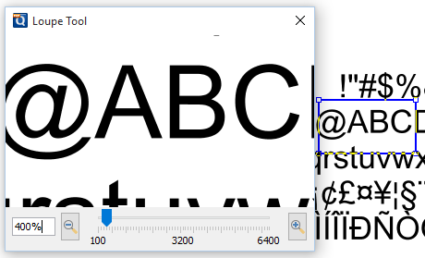

Pan and Zoom Tool
The Pan and Zoom tool is a second window will be displayed showing the portion of the page currently on screen. Drag the red box to adjust the view of the document.

Instructions:
- Click on the pan and zoom tool button on the toolbar. A second window will then be displayed showing a portion of the page currently on the screen.
- To adjust the view of the document drag the red box or use the navigation and zoom tools in the pan and zoom window
- When finished to close the tool either click on the "x" on the magnification window or press Esc on the keyboard
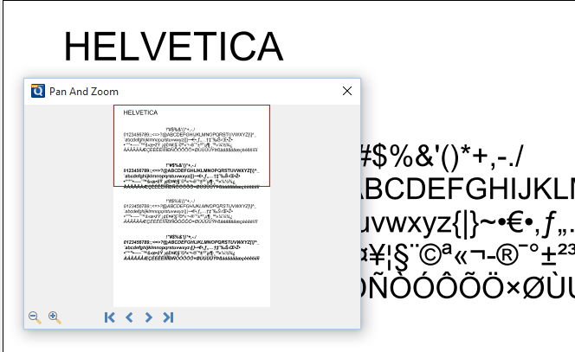

Invert Colors
Inverting colors make things much easier to read on small screens, particularly when working in a dark room, on an airplane, or at night.
Note: "To change these settings see the specific documentation for your application for detailed instructions"
For typical documents, the display will change from "Black on White" to "White on Black".
Example Document with Invert Colors Enabled:
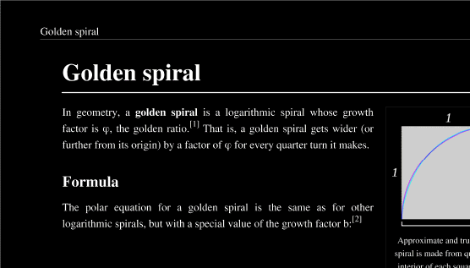

Show/Hide Layers
When viewing a document layers can be toggled on and off to create different views.

How to Show/Hide Layers in a PDF
- Access the layers pane by clicking the Layers button on the left side of the screen.
  - Note:If the layers buttons is not displayed this means that the document does not contain any layers.
- Show or hide layers by clicking the check box next to the layers name
- Continue working on the document as you normally would
Note: Toggling the layers on and off does not modify the document and will not be saved.

Side by Side Comparison
jPDFEditor has a Side by Side PDF Comparison tool that allows you to open two PDF documents in the same window next to each other to compare visually. This can be useful when comparing PDF documents that may have text or image revisions.
Note: This feature may not be available depending on what has been enabled/disabled in your distribution. See the specific documentation of your application for additional instructions.

Instructions:
- Open the initial or first document in jPDF Editor. This will become Document A in the Side by Side comparison
- Start the Side by Side comparison mode
  - Note: "See the specific documentation for your application for detailed instructions"
- Select the second document that you wish to compare with Document A. This will become Document B in the Side by Side comparison
- You will now see Document A (on the left) and Document B (on the right) opened side by side in the same jPDF Editor window.
- At any time during the comparison, using the toolbar, you can only annotate or markup any changes onto Document A.
- You can markup Document B by right clicking on Document B and selecting the tool that you wish to use. The tools available for document B are:
  - Sticky Note
  - Pencil
  - Select Text
- Once the text is selected you can right click on the highlighted and choose a text markup action.
- If you would like you can switch over to our Overlay Comparison mode by clicking on the Overlay button overlay in the top right corner of the above Document B.
Note: When switching over to Overlay Comparison if any changes have been made to Document B they will need to first be saved. jjPDF Editor will prompt you to do so when switching to Overlay Comparison.
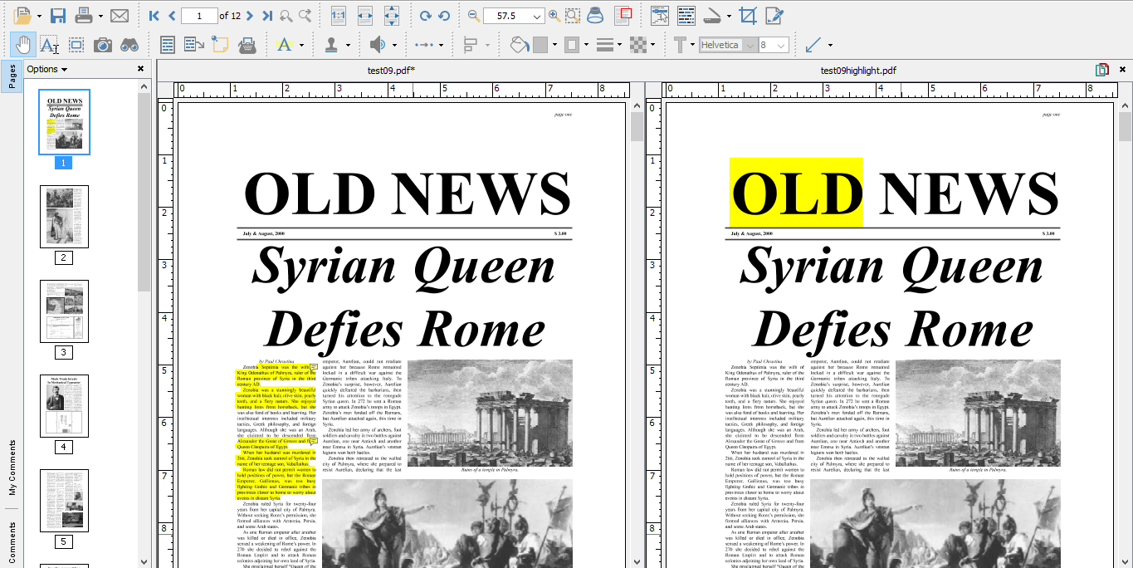

jPDFEditor comes with a new PDF Overlay Comparison feature that allows you visually compare documents by overlaying a second document onto the first using different colors to display any differences. This feature is especially useful for architects and engineers to visually identify even small differences in architectural drawing and blue prints. It can be used not only to compare PDF documents but also scans, images or text documents that have been converted to PDFs using jPDF Editor. The overlay comparison is rendered live, making it very easy to perfectly align the 2 documents, moving a pixel up or down, by using the adjustment options provided. This is useful in the case of scanned documents, where position, rotation or scale can be slightly off from one scan to the other.
Note: This feature may not be available depending on what has been enabled/disabled in your distribution. See the specific documentation of your application for additional instructions.
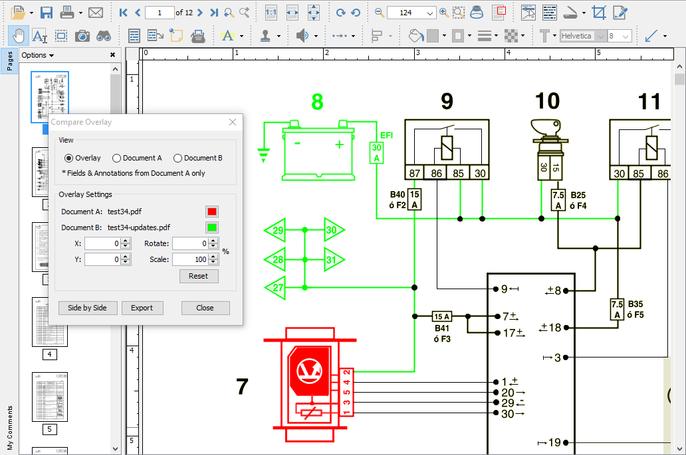

How to compare two documents using Overlay Comparison
- Open the initial or first document in jPDF Editor. This will become Document A (in Green) in the Overlay Comparison.
- Start the Overlay comparison mode
  - Note: "See the specific documentation for your application for detailed instructions"
- Select the second document that you wish to compare with Document A. This will become Document B (in Red) in the Overlay Comparison
- You will now see Document B overlayed onto Document A and the Compare Overlay dialog that can be used to make any alignment changes to Document B (in real time) if needed to correctly match up the documents.

The following adjustment options are available:

View
choose to display both or each document individually

Settings
Color - select the color of each document (the default colors generally provide the best results). See Choosing colors for overlay PDF comparison.
X & Y - adjust the X & Y values of Document B to move it left, right, up, or down
Rotate - adjust the rotation of Document B if needed
Scale - make Document B smaller or larger if needed
Note: The scale option has a minimum of 1 and a maximum value of 999.

Additional Options
Annotations & Markups - At any time during the comparison you can only annotate or markup any changes onto Document A.*
Note: It is worth noting that all annotation and text markup tools, as well as other PDF editing tools, are still active while in comparison overlay view, allowing to mark up and modify the original PDF. One can also easily switch back and forth between the overlay comparison view and the side by side comparison view (where the 2 documents are displayed side by side in a synchronized way). In side by side comparison, it is possible to annotate the second document to add sticky notes and text highlights (look under the right-click context menu).
Switching Comparison Modes - You can also switch over to our Side by Side Comparison mode by clicking on the "Side by Side" button in the Overlay Comparison dialog. When switching back and forth the scale values will be remembered until a new document is opened for comparison.
Exporting - Once you've completed your comparison you can export the comparison into a single document with the Overlay Comparison View as the as the base layer and Documents A & B as layers within the document. If you have completed your comparison and want to exit the comparison mode just close the comparison tool to return back to Document A.
- The Overlay comparison - Layer 1 (on by default) and will be rasterized (turned into an image per page).
- The original Document A - Layer 2
- The original Document B - Layer 3

Choosing Colors for Overlay Comparison
The Overlay Comparison feature allows to customize the colors of the 2 documents that are being compared. The colors are be remembered when the "Compare Overlay" dialog is closed. When changing from the default colors, we suggest using complementary colors when comparing PDF documents using the Overlay Comparison feature in jPDF Editor. Complementary colors are colors that add up to black which will ensure that the common elements on the two drawings / documents are displayed in black (overlay of the 2 complementary colors).
Using RGB (Red, Green, Blue) values, complementary colors are colors that add up to (255, 255, 255). See below for a few color pairs of complementary colors. The number in parenthesis represent the color in RGB values.

Example Colors
- Cyan (51, 204, 204) / Dark Red (204, 51, 51)These are the default colors in jPDF Editor.
- Green (0, 204, 51) / Dark Pink (255, 51, 204)
- Blue (0, 125, 255) / Orange (0, 125, 255)
- Green (0, 255, 0) / Red (0, 255, 0) Note:that the common elements in both drawings will not be as black in this color pair as the colors above because the colors do not add up to black.
Annotations and comments allow you to markup parts of the PDF. While annotations and comments are contained within the PDF they are not a part of the PDF original content. This allows them to be moved, edited, or deleted more easily. This section covers the tasks associated with annotations and comments and also provides examples of each of the markups that can be used in jPDFEditor.

Topics covered in this section:
Creating Annotations | Editing Annotations | Flattening Annotations | Pasting Clipboard Text
Setting Annotation Tool Properties | Moving Annotations | Align Annotations | Pasting a Clipboard Image
Set a Status or Check Mark | Deleting Annotations | Group annotations | Copy and Paste Annotations
 | Export Annotations

Available Annotation Types:
Below is a list of each of the annotation types and available annotations. You can comment or annotate a document with text, graphics, sound, and add hyperlinks.
Text Annotations | Shape Annotations | Text Markups
Text Box | Circle | Highlight Text
Callout | Arrow | Cross out Text
Typewriter | Line | Underline Text
Sticky Note | Square | Squiggly Underline Text
 | Pencil | Replace Text
 | Polygon | Insert Text
 | Cloud | Highlight Area
 | Polyline
Rubber Stamp Annotations | Measurement Annotations | Media & Other Annotations
Rubber Stamp | Distance | Sound
 | Perimeter | Image
 | Area | Hyperlink
 |  | Attach File
 |  | Attach File as Comment

Creating Annotations
Annotations can be created by doing the following:
From the annotations toolbar, simply click on an annotation tool, and draw the annotation by dragging the mouse on the page.
Note: Additional methods may be available to add annotations in your distribution. See the specific documentation of your application for additional instructions.
jPDFEditor has the following text annotation tools available.
Text Box: Creates a text box annotation.
Callout: Creates a callout annotation
Sticky Note: Creates a typewriter annotation.
Typewriter: Creates a sticky note annotation.

Text Box Annotations
The Text Box tool creates a text note on the document. The text is contained within a box that is created when placing a text box on the page. Once placed you can resize the shapes to reflow the text within the boxes as well as edit additional properties using the Quick Properties or Mini Toolbars.
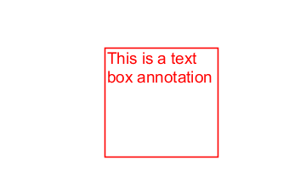

Creating a Text Box
- Select the Text Box tool by clicking the on the toolbar
- Click and drag to create the rectangle for the text box
- Type the text you wish to add in the text box
- To finish press Esc or click elsewhere on the document
Note: Text on the System Clipboard can be pasted into a PDF document as a Text Box.

Annotation Properties
To access the Text Box properties right click (Mac: Ctrl + Click) on the annotation and choose Properties in the mouse menu or click on the edit button on the Mini Toolbar. The Text Box annotation contains the following property settings.

Appearance
Border Width - Sets the width of the border line
Style - Sets the style for the border line (i.e. dotted, dashed, cloud, etc...)
Border Color - Sets the color of the border
Fill Color - Sets the fill color
Text Color - Sets the text color
Horiz Align - Sets the horizontal alignment of the text
Font - Sets the font of the text
Size - Sets the font size of the text
B - Makes all of the text Bold
I - Makes all of the text Italic
U - Makes the selected annotation text underlined
S - Marks the selected annotation text with a strikethrough
Transparency - Sets the transparency of the text annotation
Save as default - When checked this will make the selected appearance settings the default for any new Text Box annotations going forward
Locked - When checked prevents the following on the annotation: being moved or resized, editing appearance properties, & deleting the annotation.

General
Author - Allows you to edit the author
Subject - Allows you to edit the subject
Layer - Only available when the document contains layers. Sets the layer that the annotation belongs to. For more information see Assigning Comments to Layers

Status History
This tab will display and changes to the review status of the annotation including Author, Status, and Timestamp. For more details see Setting Status or Check Marks on Annotations

Callout Annotations
The callout tool creates a text note with an arrow on the document that can point to a specific spot on the page. The text is contained within a box that is created when placing the callout on the page. Once placed you can move the arrow or resize the box to reflow the text within the boxes as well as edit additional properties using the Quick Properties or Mini Toolbars.
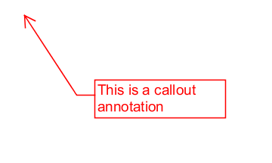

Creating a Callout
- Select the Callout tool by clicking the on the toolbar
- First click where you would like the point of the arrow to be placed then move the cursor to where you would like the attached text box to be placed
- Type the text you wish to add in the callout
- To finish press Esc or click elsewhere on the document

Annotation Properties
To access the Callout properties right click (Mac: Ctrl + Click) on the annotation and choose Properties in the mouse menu or click on the edit button on the Mini Toolbar. The Callout annotation contains the following property settings.

Appearance
Border Width - Sets the width of the border line
Style - Sets the style for the border line (i.e. dotted, dashed, cloud, etc...) Note: Choosing the cloud style on a callout only changes the text box. The line and arrow will remain solid
Border Color - Sets the color of the border
Fill Color - Sets the fill color
Text Color - Sets the text color
Horiz Align - Sets the horizontal alignment of the text
Font - Sets the font of the text
Size - Sets the font size of the text
B - Makes all of the text Bold
I - Makes all of the text Italic
U - Makes the selected annotation text underlined
S - Marks the selected annotation text with a strikethrough
Transparency - Sets the transparency of the text annotation
Save as default - When checked this will make the selected appearance settings the default for any new Callout annotations going forward
Locked - When checked prevents the following on the annotation: being moved or resized, editing appearance properties, & deleting the annotation.

General
Author - Allows you to edit the author
Subject - Allows you to edit the subject
Layer - Only available when the document contains layers. Sets the layer that the annotation belongs to. For more information see Assigning Comments to Layers

Status History
This tab will display and changes to the review status of the annotation including Author, Status, and Timestamp. For more details see Setting Status or Check Marks on Annotations

Sticky Note Annotations
The Sticky Note tool places a note on the document that is hidden until double clicked on or hovered over with the mouse. This is useful if you want to add comments to the document and not have them displayed until needed. Once created you can edit additional properties using the Quick Properties or Mini Toolbars.
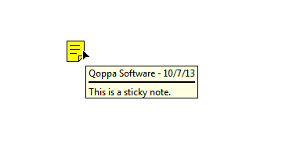

Creating a Sticky Note Annotation
- Select the Sticky Note tool by clicking the on the toolbar
- Click on the page where you would like to add the note. Once placed the Sticky Note properties dialog will be displayed to allow you to add text to the note
- Type the text you wish to add in the Note / Comment field
- Once finished click on OK to create the note

Annotation Properties
To access the Sticky Note properties right click (Mac: Ctrl + Click) on the annotation and choose Properties in the mouse menu or click on the edit button on the Mini Toolbar. The Sticky Note annotation contains the following property settings.

Appearance
Icon Color - Sets the color of the sticky note icon
Transparency - Sets the transparency of the sticky note icon
Note / Comment - Contains the text added to the Sticky Note
Save as default - When checked this will make the selected appearance settings the default for any new Sticky Note annotations going forward
Locked - When checked prevents the following on the annotation: being moved or resized, editing appearance properties, & deleting the annotation.

General
Author - Allows you to edit the author
Subject - Allows you to edit the subject
Layer - Only available when the document contains layers. Sets the layer that the annotation belongs to. For more information see Assigning Comments to Layers

Status History
This tab will display and changes to the review status of the annotation including Author, Status, and Timestamp. For more details see Setting Status or Check Marks on Annotations

Typewriter Annotations
The Typewriter tool creates text directly on the document. Useful for adding text to PDF documents that do not have interactive forms. Once created you can edit additional properties using the Quick Properties or Mini Toolbars.
Note: Line breaks must be created manually - unlike the text box and callout, the typewriter is sized by the text and line breaks added to it.
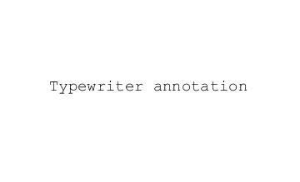

Creating a Typewriter Annotation
- Select the Typewriter tool by clicking the on the toolbar
- Click on the page where you would like to add some text
- Type the text you wish to add
- To finish press Esc or click elsewhere on the document

Annotation Properties
To access the Typewriter properties right click (Mac: Ctrl + Click) on the annotation and choose Properties in the mouse menu or click on the edit button on the Mini Toolbar. The Typewriter annotation contains the following property settings.

Appearance
Text Color - Sets the text color
Font - Sets the font of the text
Size - Sets the font size of the text
B - Makes all of the text Bold
I - Makes all of the text Italic
U - Makes the selected annotation text underlined
S - Marks the selected annotation text with a strikethrough
Transparency - Sets the transparency of the text annotation
Save as default - When checked this will make the selected appearance settings the default for any new Typewriter annotations going forward
Locked - When checked prevents the following on the annotation: being moved or resized, editing appearance properties, & deleting the annotation.

General
Author - Allows you to edit the author
Subject - Allows you to edit the subject
Layer - Only available when the document contains layers. Sets the layer that the annotation belongs to. For more information see Assigning Comments to Layers

Status History
This tab will display and changes to the review status of the annotation including Author, Status, and Timestamp. For more details see Setting Status or Check Marks on Annotations

jPDFEditor has the following shape annotation tools available.
Circle: Creates a circle annotation.
Arrow: Creates an arrow annotation.
Line: Creates a line annotation.
Square: Creates a square annotation.
Pencil: Creates a pencil annotation.
Polygon: Creates a polygon annotation.
Cloud: Creates a cloud annotation.
Polyline: Creates a polyline annotation.

Circle Annotations
The Circle tool allows you to draw a circle or ellipse on the document. Hold the Shift key while drawing to create a perfect circle. Once placed shapes can be modified by dragging any of the resize handles on the shape.
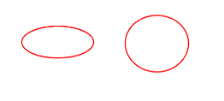

Creating a Circle Annotation
- Select the Circle tool by clicking the on the toolbar
- Click and drag to create your shape (Note:Hold the Shift key while drawing to create a perfect circle.)
  - you can also create a simple shape by just clicking on the page

Annotation Properties
To access the Circle properties right click (Mac: Ctrl + Click) on the annotation and choose Properties in the mouse menu or click on the edit button on the Mini Toolbar. The Circle annotation contains the following property settings.

Appearance
Line Width - Sets the width of the border line
Style - Sets the style for the border line (i.e. dotted, dashed, cloud, etc...)
Color - Sets the color of the border
Fill Color - Sets the fill color
Transparency - Sets the transparency of the shape
Note / Comment - A note can be added to shapes that will be displayed when hovered over by the mouse
Save as default - When checked this will make the selected appearance settings the default for any new Circle annotations going forward
Locked - When checked prevents the following on the annotation: being moved or resized, editing appearance properties, & deleting the annotation.

General
Author - Allows you to edit the author
Subject - Allows you to edit the subject
Layer - Only available when the document contains layers. Sets the layer that the annotation belongs to. For more information see Assigning Comments to Layers

Status History
This tab will display and changes to the review status of the annotation including Author, Status, and Timestamp. For more details see Setting Status or Check Marks on Annotations

Square Annotations
The Square tool allows you to draw a square or rectangle on the document. Hold the Shift key while drawing to create a perfect square. Once placed shapes can be modified by dragging any of the resize handles on the shape.
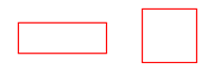

Creating a Square Annotation
- Select the Square tool by clicking the on the toolbar
- Click and drag to create your shape (Note:Hold the Shift key while drawing to create a perfect square.)
  - you can also create a simple shape by just clicking on the page

Annotation Properties
To access the Square properties right click (Mac: Ctrl + Click) on the annotation and choose Properties in the mouse menu or click on the edit button on the Mini Toolbar. The Square annotation contains the following property settings.

Appearance
Line Width - Sets the width of the border line
Style - Sets the style for the border line (i.e. dotted, dashed, cloud, etc...)
Color - Sets the color of the border
Fill Color - Sets the fill color
Transparency - Sets the transparency of the shape
Note / Comment - A note can be added to shapes that will be displayed when hovered over by the mouse
Save as default - When checked this will make the selected appearance settings the default for any new Square annotations going forward
Locked - When checked prevents the following on the annotation: being moved or resized, editing appearance properties, & deleting the annotation.

General
Author - Allows you to edit the author
Subject - Allows you to edit the subject
Layer - Only available when the document contains layers. Sets the layer that the annotation belongs to. For more information see Assigning Comments to Layers

Status History
This tab will display and changes to the review status of the annotation including Author, Status, and Timestamp. For more details see Setting Status or Check Marks on Annotations

Line Annotations
The Line tool allows you to draw a line on the document. Hold the Shift key while drawing to make horizontal, vertical, or 45 degree angle lines. Once placed shapes can be modified by dragging any of the resize handles on the shape.
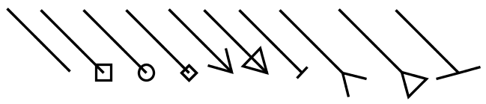

Creating a Line Annotation
- Select the Line tool by clicking the on the toolbar
- Click where you would like the line to begin and then move the cursor where you would like the line to end and click again to place the line on the page (Note:Hold the Shift key while drawing to make horizontal, vertical, or 45 degree angle lines.)

Annotation Properties
To access the Line properties right click (Mac: Ctrl + Click) on the annotation and choose Properties in the mouse menu or click on the edit button on the Mini Toolbar. The Line annotation contains the following property settings.

Appearance
Line Width - Sets the width of the border line
Line Start - Sets the shape to be used at the beginning of the line
Style - Sets the style for the border line (i.e. dotted, dashed, cloud, etc...)
Line End - Sets the shape to be used at the end of the line
Color - Sets the color of the border
Fill Color - Sets the fill color of the shapes at the end of the line
Transparency - Sets the transparency of the shape
Note / Comment - A note can be added to shapes that will be displayed when hovered over by the mouse
Save as default - When checked this will make the selected appearance settings the default for any new Line annotations going forward
Locked - When checked prevents the following on the annotation: being moved or resized, editing appearance properties, & deleting the annotation.

General
Author - Allows you to edit the author
Subject - Allows you to edit the subject
Layer - Only available when the document contains layers. Sets the layer that the annotation belongs to. For more information see Assigning Comments to Layers

Status History
This tab will display and changes to the review status of the annotation including Author, Status, and Timestamp. For more details see Setting Status or Check Marks on Annotations

Arrow Annotations
The Arrow tool allows you to draw an arrow on the document. The arrow is essentially a line with a default ending using an arrow shape. Hold the Shift key while drawing to make horizontal, vertical, or 45 degree angle lines. Once placed shapes can be modified by dragging any of the resize handles on the shape.
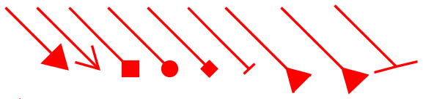

Creating an Arrow Annotation
- Select the Arrow tool by clicking the on the toolbar
- Click where you would like the arrow to begin and then move the cursor where you would like the arrow to end and click again to place the arrow on the page (Note:Hold the Shift key while drawing to make horizontal, vertical, or 45 degree angle lines.)

Annotation Properties
To access the Arrow properties right click (Mac: Ctrl + Click) on the annotation and choose Properties in the mouse menu or click on the edit button on the Mini Toolbar. The Arrow annotation contains the following property settings.

Appearance
Line Width - Sets the width of the border line
Line Start - Sets the shape to be used at the beginning of the line
Style - Sets the style for the border line (i.e. dotted, dashed, cloud, etc...)
Line End - Sets the shape to be used at the end of the line
Color - Sets the color of the border
Fill Color - Sets the fill color of the shapes at the end of the line
Transparency - Sets the transparency of the shape
Note / Comment - A note can be added to shapes that will be displayed when hovered over by the mouse
Save as default - When checked this will make the selected appearance settings the default for any new Arrow annotations going forward
Locked - When checked prevents the following on the annotation: being moved or resized, editing appearance properties, & deleting the annotation.

General
Author - Allows you to edit the author
Subject - Allows you to edit the subject
Layer - Only available when the document contains layers. Sets the layer that the annotation belongs to. For more information see Assigning Comments to Layers

Status History
This tab will display and changes to the review status of the annotation including Author, Status, and Timestamp. For more details see Setting Status or Check Marks on Annotations

Pencil Annotations
The Pencil tool allows you to draw free hand shapes and text on the document. Pencil annotations can consist of multiple marks or gestures. The Delay property on the pencil tool specifies the amount of time to wait before completing the pencil annotation. Once created pencil shapes can be resized by dragging any of the resize handles on the shape.


Creating a Pencil Annotation
- Select the Pencil tool by clicking the on the toolbar
- Click and drag to create your free hand shape.
- Release the mouse to complete the line
  - Note:There is a delay between when the mouse is released and when the annotation is placed. This is to allow you to create multiple lines (such as drawing a signature) that can be a part of the same single annotation. This delay can be adjusted in Comments Preferences or by changing the default using the properties dialog.

Annotation Properties
To access the Pencil properties right click (Mac: Ctrl + Click) on the annotation and choose Properties in the mouse menu or click on the edit button on the Mini Toolbar. The Pencil annotation contains the following property settings.

Appearance
Line Width - Sets the width of the border line
Color - Sets the color of the border
Transparency - Sets the transparency of the shape
Note / Comment - A note can be added to shapes that will be displayed when hovered over by the mouse
Save as default - When checked this will make the selected appearance settings the default for any new Pencil annotations going forward
Locked - When checked prevents the following on the annotation: being moved or resized, editing appearance properties, & deleting the annotation.

General
Author - Allows you to edit the author
Subject - Allows you to edit the subject
Layer - Only available when the document contains layers. Sets the layer that the annotation belongs to. For more information see Assigning Comments to Layers

Status History
This tab will display and changes to the review status of the annotation including Author, Status, and Timestamp. For more details see Setting Status or Check Marks on Annotations

Delay Setting
The Delay property on the pencil tool specifies the amount of time to wait before completing the pencil annotation. This is to allow you to create multiple lines (such as drawing a signature) that can be a part of the same single annotation.

Polygon Annotations
The Polygon tool allows you to create shapes and outlines with an arbitrary number of sides on the document. Hold the Shift key while drawing to make horizontal, vertical, or 45 degree angle lines. Once placed shapes can be modified by dragging any of the resize handles on the vertices of the shape.

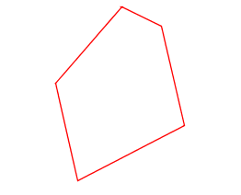

Creating a Polygon Annotation
- Select the Polygon tool by clicking the on the toolbar
- Click where you would like the first line to begin
- Continue clicking on the document to create as many vertices as you need (Note:Hold the Shift key while drawing to make horizontal, vertical, or 45 degree angle lines.)
- When finished, double-click, press Enter on the keyboard, or right-click and select Complete from the menu to complete the shape

Annotation Properties
To access the Polygon properties right click (Mac: Ctrl + Click) on the annotation and choose Properties in the mouse menu or click on the edit button on the Mini Toolbar. The Polygon annotation contains the following property settings.

Appearance
Line Width - Sets the width of the border line
Style - Sets the style for the border line (i.e. dotted, dashed, cloud, etc...)
Color - Sets the color of the border
Fill Color - Sets the fill color
Transparency - Sets the transparency of the shape
Note / Comment - A note can be added to shapes that will be displayed when hovered over by the mouse
Save as default - When checked this will make the selected appearance settings the default for any new Polygon annotations going forward
Locked - When checked prevents the following on the annotation: being moved or resized, editing appearance properties, & deleting the annotation.

General
Author - Allows you to edit the author
Subject - Allows you to edit the subject
Layer - Only available when the document contains layers. Sets the layer that the annotation belongs to. For more information see Assigning Comments to Layers

Status History
This tab will display and changes to the review status of the annotation including Author, Status, and Timestamp. For more details see Setting Status or Check Marks on Annotations

Cloud Annotations
The Cloud tool allows you to create shapes and outlines with an arbitrary number of sides on the document. The cloud is essentially a Cloud with a default line style using a cloud shape. Hold the Shift key while drawing to make horizontal, vertical, or 45 degree angle lines. Once placed shapes can be modified by dragging any of the resize handles on the vertices of the shape.
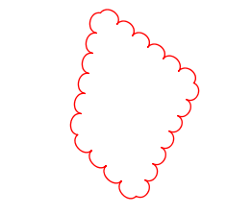

Creating a Cloud Annotation
- Select the Cloud tool by clicking the on the toolbar
- Click where you would like the first line to begin
- Continue clicking on the document to create as many vertices as you need (Note:Hold the Shift key while drawing to make horizontal, vertical, or 45 degree angle lines.)
- When finished, double-click, press Enter on the keyboard, or right-click and select Complete from the menu to complete the shape

Annotation Properties
To access the Cloud properties right click (Mac: Ctrl + Click) on the annotation and choose Properties in the mouse menu or click on the edit button on the Mini Toolbar. The Cloud annotation contains the following property settings.

Appearance
Line Width - Sets the width of the border line
Style - Sets the style for the border line (i.e. dotted, dashed, cloud, etc...)
Color - Sets the color of the border
Fill Color - Sets the fill color
Transparency - Sets the transparency of the shape
Note / Comment - A note can be added to shapes that will be displayed when hovered over by the mouse
Save as default - When checked this will make the selected appearance settings the default for any new Cloud annotations going forward
Locked - When checked prevents the following on the annotation: being moved or resized, editing appearance properties, & deleting the annotation.

General
Author - Allows you to edit the author
Subject - Allows you to edit the subject
Layer - Only available when the document contains layers. Sets the layer that the annotation belongs to. For more information see Assigning Comments to Layers

Status History
This tab will display and changes to the review status of the annotation including Author, Status, and Timestamp. For more details see Setting Status or Check Marks on Annotations

Polyline Annotation
The Polyline tool allows you to create shapes and outlines with an arbitrary number of sides on the document. The Polyline works exactly the same as the Polygon only it can have an open ending or side. Hold the Shift key while drawing to make horizontal, vertical, or 45 degree angle lines. Once placed shapes can be modified by dragging any of the resize handles on the vertices of the shape.
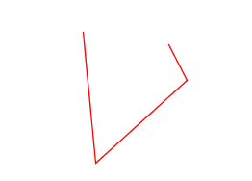

Creating a Polyline Annotation
- Select the Polyline tool by clicking the on the toolbar
- Click where you would like the first line to begin
- Continue clicking on the document to create as many vertices as you need (Note:Hold the Shift key while drawing to make horizontal, vertical, or 45 degree angle lines.)
- When finished, double-click, press Enter on the keyboard, or right-click and select Complete from the menu to complete the shape

Annotation Properties
To access the Polyline properties right click (Mac: Ctrl + Click) on the annotation and choose Properties in the mouse menu or click on the edit button on the Mini Toolbar. The Polyline annotation contains the following property settings.

Appearance
Line Width - Sets the width of the border line
Style - Sets the style for the border line (i.e. dotted, dashed, Polyline, etc...)
Color - Sets the color of the border
Transparency - Sets the transparency of the shape
Note / Comment - A note can be added to shapes that will be displayed when hovered over by the mouse
Save as default - When checked this will make the selected appearance settings the default for any new Polyline annotations going forward
Locked - When checked prevents the following on the annotation: being moved or resized, editing appearance properties, & deleting the annotation.

General
Author - Allows you to edit the author
Subject - Allows you to edit the subject
Layer - Only available when the document contains layers. Sets the layer that the annotation belongs to. For more information see Assigning Comments to Layers

Status History
This tab will display and changes to the review status of the annotation including Author, Status, and Timestamp. For more details see Setting Status or Check Marks on Annotations
jPDFEditor has the following Text Markup tools available.
Highlight Text: Creates a text highlight annotation
Cross Out Text: Creates a text crossout annotation
Underline Text: Creates a text underline annotation
Squiggly Underline Text: Creates a squiggly underline text annotation
Replace Text: Creates a replace text annotation
Insert Text: Creates an insert text annotation
Area Highlight: Highlights an area on the page

Text Highlight Markup
The Text Highlight tool allows you to select and highlight text, similar to using a highlighter on paper, within the document.
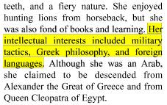

Creating a Text Highlight Markup
- Select the Text Highlight tool by clicking the on the toolbar
- Click and drag the mouse over the text that you wish to markup
  - For rectangular text selection, hold down Ctrl (Command for OSX) while dragging the mouse. The cursor will change to to indicate that a different selection mode is active.
- To finish, release the mouse and all text within the selected area will be impacted

Annotation Properties
To access the Text Highlight properties right click (Mac: Ctrl + Click) on the annotation and choose Properties in the mouse menu or click on the edit button on the Mini Toolbar. The Text Highlight Markup contains the following property settings.

Appearance
Markup Type - Allows you to change the type of text markup on the selected text
Transparency - Sets the transparency of the text markup
Color - Allows you to set the color of the text markup
Note / Comment - A note can be added to text markups that will be displayed when hovered over by the mouse
Save as default - When checked this will make the selected appearance settings the default for any new Text Highlight markups going forward
Locked - When checked prevents the following on the annotation: being moved or resized, editing appearance properties, & deleting the annotation.

General
Author - Allows you to edit the author
Subject - Allows you to edit the subject
Layer - Only available when the document contains layers. Sets the layer that the annotation belongs to. For more information see Assigning Comments to Layers

Status History
This tab will display and changes to the review status of the annotation including Author, Status, and Timestamp. For more details see Setting Status or Check Marks on Annotations

Cross Out Text Markup
The Cross Out Text tool allows you to select and cross out text, similar to drawing a line through text on a page, within the document.
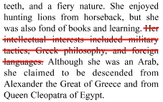

Creating a Cross Out Text Markup
- Select the Cross Out Text tool by clicking the on the toolbar
- Click and drag the mouse over the text that you wish to markup
  - For rectangular text selection, hold down Ctrl (Command for OSX) while dragging the mouse. The cursor will change to indicate that a different selection mode is active.
- To finish, release the mouse and all text within the selected area will be impacted

Annotation Properties
To access the Cross Out Text properties right click (Mac: Ctrl + Click) on the annotation and choose Properties in the mouse menu or click on the edit button on the Mini Toolbar. The Cross Out Text Markup contains the following property settings.

Appearance
Markup Type - Allows you to change the type of text markup on the selected text
Transparency - Sets the transparency of the text markup
Color - Allows you to set the color of the text markup
Note / Comment - A note can be added to text markups that will be displayed when hovered over by the mouse
Save as default - When checked this will make the selected appearance settings the default for any new Cross Out Text markups going forward
Locked - When checked prevents the following on the annotation: being moved or resized, editing appearance properties, & deleting the annotation.

General
Author - Allows you to edit the author
Subject - Allows you to edit the subject
Layer - Only available when the document contains layers. Sets the layer that the annotation belongs to. For more information see Assigning Comments to Layers

Status History
This tab will display and changes to the review status of the annotation including Author, Status, and Timestamp. For more details see Setting Status or Check Marks on Annotations

Text Underline Markup
The UnderlineText tool allows you to select and underline text, similar to drawing a line under text on a page, within the document.
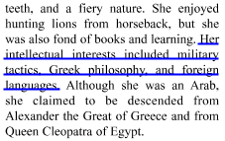

Creating an Underline Text Markup
- Select the Underline Text tool by clicking the on the toolbar
- Click and drag the mouse over the text that you wish to markup
  - For rectangular text selection, hold down Ctrl (Command for OSX) while dragging the mouse. The cursor will change to indicate that a different selection mode is active.
- To finish, release the mouse and all text within the selected area will be impacted

Annotation Properties
To access the Underline Text properties right click (Mac: Ctrl + Click) on the annotation and choose Properties in the mouse menu or click on the edit button on the Mini Toolbar. The Underline Text Markup contains the following property settings.

Appearance
Markup Type - Allows you to change the type of text markup on the selected text
Transparency - Sets the transparency of the text markup
Color - Allows you to set the color of the text markup
Note / Comment - A note can be added to text markups that will be displayed when hovered over by the mouse
Save as default - When checked this will make the selected appearance settings the default for any new Underline Text markups going forward
Locked - When checked prevents the following on the annotation: being moved or resized, editing appearance properties, & deleting the annotation.

General
Author - Allows you to edit the author
Subject - Allows you to edit the subject
Layer - Only available when the document contains layers. Sets the layer that the annotation belongs to. For more information see Assigning Comments to Layers

Status History
This tab will display and changes to the review status of the annotation including Author, Status, and Timestamp. For more details see Setting Status or Check Marks on Annotations

Squiggly Underline Text Markup
The Squiggly UnderlineText tool allows you to select and add a squiggly underline below the text on the document.
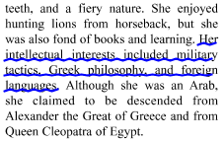

Creating a Squiggly Underline Text Markup
- Select the Squiggly Underline Text tool by clicking the on the toolbar
- Click and drag the mouse over the text that you wish to markup
  - For rectangular text selection, hold down Ctrl (Command for OSX) while dragging the mouse. The cursor will change to indicate that a different selection mode is active.
- To finish, release the mouse and all text within the selected area will be impacted

Annotation Properties
To access the Squiggly Underline Text properties right click (Mac: Ctrl + Click) on the annotation and choose Properties in the mouse menu or click on the edit button on the Mini Toolbar. The Squiggly Underline Text Markup contains the following property settings.

Appearance
Markup Type - Allows you to change the type of text markup on the selected text
Transparency - Sets the transparency of the text markup
Color - Allows you to set the color of the text markup
Note / Comment - A note can be added to text markups that will be displayed when hovered over by the mouse
Save as default - When checked this will make the selected appearance settings the default for any new Squiggly Underline Text markups going forward
Locked - When checked prevents the following on the annotation: being moved or resized, editing appearance properties, & deleting the annotation.

General
Author - Allows you to edit the author
Subject - Allows you to edit the subject
Layer - Only available when the document contains layers. Sets the layer that the annotation belongs to. For more information see Assigning Comments to Layers

Status History
This tab will display and changes to the review status of the annotation including Author, Status, and Timestamp. For more details see Setting Status or Check Marks on Annotations

Text Insert Markup
The Insert Text tool allows you to mark a specific point on the page with an annotation showing that text needs to be inserted at that location.
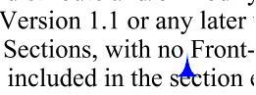

Creating an Insert Text Markup
- Select the Insert Text tool by clicking the on the toolbar
- The cursor will become a crosshair. Click the crosshair on the desired location for the insert text annotation.
- To finish, release the mouse and all text within the selected area will be impacted
- In the properties dialog, select the color of the annotation and add a comment in the content area then click on the Save button.

Annotation Properties
To access the Insert Text properties right click (Mac: Ctrl + Click) on the annotation and choose Properties in the mouse menu or click on the edit button on the Mini Toolbar. The Insert Text Markup contains the following property settings.

Appearance
Color - Allows you to set the color of the text markup
Size - Sets the size of the insert text annotation symbol
Transparency - Sets the transparency of the text markup
Note / Comment - A note can be added to text markups that will be displayed when hovered over by the mouse
Save as default - When checked this will make the selected appearance settings the default for any new Insert Text markups going forward
Locked - When checked prevents the following on the annotation: being moved or resized, editing appearance properties, & deleting the annotation.

General
Author - Allows you to edit the author
Subject - Allows you to edit the subject
Layer - Only available when the document contains layers. Sets the layer that the annotation belongs to. For more information see Assigning Comments to Layers

Status History
This tab will display and changes to the review status of the annotation including Author, Status, and Timestamp. For more details see Setting Status or Check Marks on Annotations

Replace Text Markup
The Replace Text tool allows you to mark text for deletion and to replace it with something else using a single annotation.
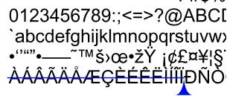

Creating a Replace Text Markup
- Select the Replace Text tool by clicking the on the toolbar
- Click and drag the mouse over the text that you wish to markup
  - For rectangular text selection, hold down Ctrl (Command for OSX) while dragging the mouse. The cursor will change to indicate that a different selection mode is active.
- To finish, release the mouse and all text within the selected area will be impacted
- In the properties dialog, select the color of the annotation and add a comment in the content area then click on the Save button.

Annotation Properties
To access the Replace Text properties right click (Mac: Ctrl + Click) on the annotation and choose Properties in the mouse menu or click on the edit button on the Mini Toolbar. The Replace Text Markup contains the following property settings.

Appearance
Markup Type - Allows you to change the type of text markup on the selected text
Transparency - Sets the transparency of the text markup
Color - Allows you to set the color of the text markup
Note / Comment - A note can be added to text markups that will be displayed when hovered over by the mouse
Save as default - When checked this will make the selected appearance settings the default for any new Replace Text markups going forward
Locked - When checked prevents the following on the annotation: being moved or resized, editing appearance properties, & deleting the annotation.

General
Author - Allows you to edit the author
Subject - Allows you to edit the subject
Layer - Only available when the document contains layers. Sets the layer that the annotation belongs to. For more information see Assigning Comments to Layers

Status History
This tab will display and changes to the review status of the annotation including Author, Status, and Timestamp. For more details see Setting Status or Check Marks on Annotations

Area Highlight
Add highlights to scanned documents without text objects.
Note: An area highlight annotation is simply a square annotation with a transparent background and no border (line width = 0).

Creating an Area Highlight
- Select the Area Highlight tool by clicking the on the toolbar
- Click and drag to highlight an area (Note:Hold the Shift key while drawing to create a perfect square.)

Annotation Properties
To access the Area Highlight properties right click (Mac: Ctrl + Click) on the annotation and choose Properties in the mouse menu or click on the edit button on the Mini Toolbar. The Area Highlight annotation contains the following property settings.

Appearance
Line Width - Sets the width of the border line
Style - Sets the style for the border line (i.e. dotted, dashed, cloud, etc...)
Color - Sets the color of the border
Fill Color - Sets the fill color
Transparency - Sets the transparency of the shape
Note / Comment - A note can be added to shapes that will be displayed when hovered over by the mouse
Save as default - When checked this will make the selected appearance settings the default for any new Area Highlights going forward
Locked - When checked prevents the following on the annotation: being moved or resized, editing appearance properties, & deleting the annotation.

General
Author - Allows you to edit the author
Subject - Allows you to edit the subject
Layer - Only available when the document contains layers. Sets the layer that the annotation belongs to. For more information see Assigning Comments to Layers

Status History
This tab will display and changes to the review status of the annotation including Author, Status, and Timestamp. For more details see Setting Status or Check Marks on Annotations
jPDFEditor is able to apply Rubber Stamp annotations to PDF Documents. jPDF Editor comes with some standard rubber stamps but additional text, image, and custom stamps can also be created.
Rubber Stamp Annotation: Creating a rubber stamp annotation
Rotating Rubber Stamps: How to rotate rubber stamps
Importing Image as Stamp: How to quickly import an image as a stamp

Rubber Stamp Annotation
The Rubber Stamp tool allows you to place a designated stamp on the page similar to using an ink stamp on paper.


Applying a Rubber Stamp Annotation
From the toolbar, click on the Rubber Stamp button, and select the stamp that you wish to use. Then click the document where you would like to apply the stamp.

Annotation Properties
To access the Rubber Stamp properties right click (Mac: Ctrl + Click) on the annotation and choose Properties in the mouse menu or click on the edit button on the Mini Toolbar. The Rubber Stamp contains the following property settings.

Appearance
Transparency - Sets the transparency of the rubber stamp
Rotation - Allows you to set the Rotation of the rubber stamp
Note / Comment - A note can be added to rubber stamps that will be displayed when hovered over by the mouse
Save as default - When checked this will make the selected appearance settings the default for any new Rubber Stamps going forward
Locked - When checked prevents the following on the annotation: being moved or resized, editing appearance properties, & deleting the annotation.

General
Author - Allows you to edit the author
Subject - Allows you to edit the subject
Layer - Only available when the document contains layers. Sets the layer that the annotation belongs to. For more information see Assigning Comments to Layers

Status History
This tab will display and changes to the review status of the annotation including Author, Status, and Timestamp. For more details see Setting Status or Check Marks on Annotations

Rotating a Rubber Stamp
There are two ways to rotate a stamp:

Using the Stamp Rotation Handle
Select the stamp that you wish to rotate. Then click and drag the handle to rotate the stamp.
Note: Hold the Shift key while dragging to rotate the stamp in set increments.
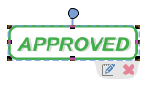

Using the Stamp Properties
To access the Rubber Stamp properties, right click (Mac: Ctrl + Click) on the annotation and choose Properties in the mouse menu or click on the edit button on the Mini Toolbar. Then change the rotation value to the desired rotation
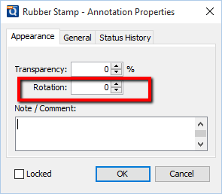

Importing Image as Stamp
Images can be imported directly as a stamp without having to create and save the stamp. Any of the any of the supported image formats (*png, *jpg, *jpeg, *jpe, *gif, *tif & *tiff.) can be used.
Note: When importing an image directly as a stamp the image will be converted to a JPEG and inserted as is.

Directions
- Click on the Image button
- Use the file chooser select the image you wish to use
- Then click the document where you would like to apply the stamp.
Once an image stamp has been applied to a page, it is possible to flatten it so the image is painted directly into the content of the PDF document itself instead of being an annotation sitting on top of it.
jPDFEditor is able to create measurement annotations to measure distance, perimeter, and area within a PDF.
Distance Annotation: Creates a distance measurement
Perimeter Annotation: Creates a perimeter measurement
Area Annotation: Creates an area measurement
Calibrating Measurement Annotations: How to calibrate measurements

Distance Annotation
The Distance Measurement Annotation is used to calculate the length a single linear measurement. Once placed measurements can be modified by dragging any of the vertices on the measurement and the values will be updated as well.
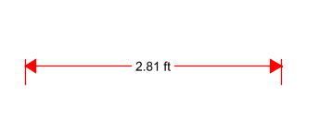

Creating a Distance Measurement
- Select the Distance tool by clicking the button on the toolbar
- The measurement dialog will be displayed where you can set the scale and precision (and calibrate if needed) for the measurement prior to drawing the annotation.
- Click where you would like the measurement to begin and then move the cursor where you would like the measurement to end and click again to place the measurement on the page (Note:Hold the Shift key while drawing to make horizontal, vertical, or 45 degree angle lines.)

Annotation Properties
To access the Distance properties right click (Mac: Ctrl + Click) on the annotation and choose Properties in the mouse menu or click on the edit button on the Mini Toolbar. The Distance measurement contains the following property settings.

Appearance
Line Width - Sets the width of the line
Line Start - Sets the shape to be used at the beginning of the line
Style - Sets the style for the line (i.e. dotted, dashed, cloud, etc...)
Line End - Sets the shape to be used at the end of the line
Color - Sets the color of the line
Fill Color - Sets the fill color of the shapes at the end of the line
Transparency - Sets the transparency of the measurement
Note / Comment - Contains two fields. The first is a comment field that allows you to add an additional comment to the measurement if needed. The second is the measurement value and can not be edited.
Save as default - When checked this will make the selected appearance settings the default for any new Distance annotations going forward
Locked - When checked prevents the following on the annotation: being moved or resized, editing appearance properties, & deleting the annotation.

General
Author - Allows you to edit the author
Subject - Allows you to edit the subject
Layer - Only available when the document contains layers. Sets the layer that the annotation belongs to. For more information see Assigning Comments to Layers

Status History
This tab will display and changes to the review status of the annotation including Author, Status, and Timestamp. For more details see Setting Status or Check Marks on Annotations

Perimeter Annotation
The Perimeter Measurement Annotation is used to calculate the length of all sides of a shape or a multi-segment line. Once placed measurements can be modified by dragging any of the vertices on the measurement and the values will be updated as well.
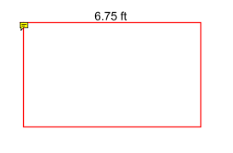

Creating a Perimeter Measurement
- Select the Perimeter tool by clicking the button on the toolbar
- The measurement dialog will be displayed where you can set the scale and precision (and calibrate if needed) for the measurement prior to drawing the annotation.
- Click where you would like the first line to begin
- Continue clicking on the document to create as many vertices as you need (Note:Hold the Shift key while drawing to make horizontal, vertical, or 45 degree angle lines.)
- When finished, double-click, press Enter on the keyboard, or right-click and select Complete from the menu to complete the measurement shape

Annotation Properties
To access the Perimeter properties right click (Mac: Ctrl + Click) on the annotation and choose Properties in the mouse menu or click on the edit button on the Mini Toolbar. The Perimeter measurement contains the following property settings.

Appearance
Line Width - Sets the width of the line
Style - Sets the style for the line (i.e. dotted, dashed, cloud, etc...)
Color - Sets the color of the line
Transparency - Sets the transparency of the measurement
Note / Comment - Contains two fields. The first is a comment field that allows you to add an additional comment to the measurement if needed. The second is the measurement value and can not be edited.
Save as default - When checked this will make the selected appearance settings the default for any new Perimeter annotations going forward
Locked - When checked prevents the following on the annotation: being moved or resized, editing appearance properties, & deleting the annotation.

General
Author - Allows you to edit the author
Subject - Allows you to edit the subject
Layer - Only available when the document contains layers. Sets the layer that the annotation belongs to. For more information see Assigning Comments to Layers

Status History
This tab will display and changes to the review status of the annotation including Author, Status, and Timestamp. For more details see Setting Status or Check Marks on Annotations

Area Annotation
The Area Measurement Annotation is used to calculate the area of a given shape. Once placed measurements can be modified by dragging any of the vertices on the measurement and the values will be updated as well.
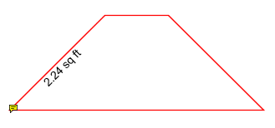

Creating a Perimeter Measurement
- Select the Area tool by clicking the button on the toolbar
- The measurement dialog will be displayed where you can set the scale and precision (and calibrate if needed) for the measurement prior to drawing the annotation.
- Click where you would like the first line to begin
- Continue clicking on the document to create as many vertices as you need (Note:Hold the Shift key while drawing to make horizontal, vertical, or 45 degree angle lines.)
- When finished, double-click, press Enter on the keyboard, or right-click and select Complete from the menu to complete the measurement shape

Annotation Properties
To access the Area properties right click (Mac: Ctrl + Click) on the annotation and choose Properties in the mouse menu or click on the edit button on the Mini Toolbar. The Area measurement contains the following property settings.

Appearance
Line Width - Sets the width of the line
Style - Sets the style for the line (i.e. dotted, dashed, cloud, etc...)
Color - Sets the color of the line
Transparency - Sets the transparency of the measurement
Fill Color - Sets the fill color of the area annotation
Note / Comment - Contains two fields. The first is a comment field that allows you to add an additional comment to the measurement if needed. The second is the measurement value and can not be edited.
Save as default - When checked this will make the selected appearance settings the default for any new Area annotations going forward
Locked - When checked prevents the following on the annotation: being moved or resized, editing appearance properties, & deleting the annotation.

General
Author - Allows you to edit the author
Subject - Allows you to edit the subject
Layer - Only available when the document contains layers. Sets the layer that the annotation belongs to. For more information see Assigning Comments to Layers

Status History
This tab will display and changes to the review status of the annotation including Author, Status, and Timestamp. For more details see Setting Status or Check Marks on Annotations

Calibrating Measurement Annotations
Measurements can be calibrated prior to being placed on the page. This can be done manually if the scale is known or automatically using the calibrate tool. If needed a separate scale can be set for both the X and Y axis. This allows you to make accurate measurements based on the scale determined by the PDF.
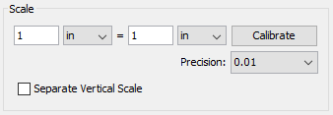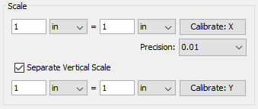

How to Calibrate Measurements

Manual Calibration
Set the measurement scale manually
- Start a measurement annotation tool (Distance, Perimeter, or Area)
- In the dialog enter the scale and units using the fields provided.
- Once complete you can continue measuring with the tool selected as normal.

Calibration Tool
Set the scale directly from an existing measurement on the page.
- Start a measurement annotation tool (Distance, Perimeter, or Area)
- Click the Calibrate button.
- A dialog will be displayed with instructions on how to calibrate the measurements "Select two points to calibrate the measuring tool", click OK
- Find a known length on the document (for example a scale an architectural drawing or previously measured segment)
- Click on the beginning point of the known scale then click on the end point of the known scale to finish the line. (Note:Hold the Shift key while drawing to make horizontal, vertical, or 45 degree angle lines.)
- Enter the distance and the units between the two points that the line represents.
- Click OK to apply this scale to the measurement dialog.
- Once complete you can continue measuring with the tool selected as normal.
Sound: Embedded audio files that can be played when clicked
Image: Images that are placed on the document as an image stamp
Hyperlink: Links that can have actions
Attach File: Attaches a file within the PDF
Attach File as Comment: Attaches a file within the PDF and displays an icon that can be clicked on to view the file

Image Annotation
Images can be imported directly as a stamp without having to create and save the stamp. Any of the supported image formats (*png, *jpg, *jpeg, *jpe, *gif, *tif & *tiff.) can be used.
Note: When importing an image directly as a stamp the image will be converted to a JPEG and inserted as is.

Creating an Image Annotation
- Select the Image tool by clicking the on the toolbar
- Use the file chooser select the image you wish to use
- Click on the page where you would like to add the image annotation.

Annotation Properties
To access the Image Stamp properties right click (Mac: Ctrl + Click) on the annotation and choose Properties in the mouse menu or click on the edit button on the Mini Toolbar. The Image contains the following property settings.

Appearance
Transparency - Sets the transparency of the image
Rotation - Allows you to set the Rotation of the image
Note / Comment - A note can be added to image stamps that will be displayed when hovered over by the mouse
Locked - When checked prevents the following on the annotation: being moved or resized, editing appearance properties, & deleting the annotation.

General
Author - Allows you to edit the author
Subject - Allows you to edit the subject
Layer - Only available when the document contains layers. Sets the layer that the annotation belongs to. For more information see Assigning Comments to Layers

Status History
This tab will display and changes to the review status of the annotation including Author, Status, and Timestamp. For more details see Setting Status or Check Marks on Annotations

Sound Annotation
The Sound annotation tool allows you to add a sound annotation to a page either from an existing file (.au, .aiff, or .wav sound file) or a microphone recording.
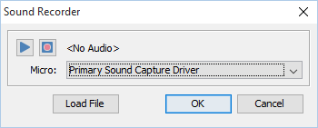

Creating a Sound Annotation
- Select the Sound tool by clicking the on the toolbar
- Click on the page where you would like to add the sound annotation. Once placed the Sound properties dialog will be displayed showing the microphone recording tools.
  - Alternatively, you can attach an existing file by clicking Load File and then browse to the file you wish to attach. (only .au, .aiff, or .wav files are supported)
- Select a microphone and then click the button to start recording and the to stop recording. To listen to the recording click on the button
- Once finished click on OK to save and create the sound annotation

Annotation Properties
To access the Sound annotation properties or listen to the audio double click on the sound annotation, right click (Mac: Ctrl + Click) on the annotation and choose Properties in the mouse menu, or click on the edit button on the Mini Toolbar. The Sound annotation contains the following property settings.
Icon Color - The color of the sound annotation icon
Sound Properties - The properties of the attached audio file or recording
- Allows you to play the attached audio file
- Stops the playing audio
Use the link tool to create and edit links within the PDF. Links can also be automatically generated and removed.
Creating Links: How to create links
Custom Link Actions: Actions available when creating a link

Creating Links
The Link tool allows you to designate an area within the PDF that can be linked to a web page, pages in a PDF document, or even have custom actions.
- Select the Link tool by clicking the on the toolbar
- Click and drag to select the area that you wish to make a link (Note:Hold the Shift key while drawing to create a perfect square.)
  - You can also select the desired text area and right-click on the selected text (CTRL + Click on Mac), choose "Create Link" in the context menu.
- After the link annotation is added, the Link Properties dialog is displayed.
- Set the options for the link:
  - Appearance

    - Border Width - Sets the width of the border line
    - Border Color - Sets the color of the border line
  - Action

    - Open a web link. Examples of valid links:

      - http://www.qoppa.com
      - ftp://ftp.site.com
      - file:c:\qoppa\temp.txt
      - mailto:johndoe@gmail.com
    - Go to a page in this document

      - Page Number - the page number of the document to link to
      - Zoom - Set the page fit when navigating to the page
      - Percent - The zoom level for Custom zoom setting
      - Set Visually - Allows you to set the location of the link visually

    - Go to a page in another document

      - Page Number - the page number of the document to link to
      - Document - The full path to the file to open. Click on the "..." button to open a file chooser and navigate to the file you wish to select.
    - Custom link - Allows you to add custom Link Actions from a list of available actions.
- Once complete, click OK to create the link

Link Properties
To access the Link properties right click (Mac: Ctrl + Click) on the annotation and choose Properties in the mouse menu or click on the edit button on the Mini Toolbar. Links contain the following property settings.
Locked - When checked prevents the following on the annotation: being moved or resized, editing appearance properties, & deleting the annotation.

Appearance
Border Width - Sets the width of the border line
Border Color - Sets the color of the border line
Style - Sets the border style for the link
- Solid: Creates a solid line
- Dashed: Creates a dashed line
- Underlined: Creates a bottom line only

Action
The Action Panel displays a list of the current actions associated with the link. Actions can be added, edited, or deleted using the buttons below the actions list.
Add - Adds a custom Link Action from a list of available actions.
Edit - Edits the currently selected action from the list
Remove - Removes the currently selected action from the list

Custom Link Actions
When adding a link to a PDF document custom actions can be created instead of the standard link options. Below is a list of the each of the custom actions and their settings.

Go to a page in this document
Sets the link to go to a page within the current document
- Page Number - the page number of the document to link to
- Zoom - Set the page fit when navigating to the page
- Percent - The zoom level for Custom zoom setting
- Set Visually - Allows you to set the location of the link visually

Go to a page in another document
Sets the link to go to a page within a different designated document
- Page Number - the page number of the document to link to
- Document - The full path to the document to open. Click on the "..." button to open a file chooser and navigate to the file you wish to select.
Note: When sending this document to other users this action may not work if the file is not in the same location on the users computer. To make sure the file is included with the PDF when sending to another user try using a File Attachment instead.

Show/Hide Fields
Sets the link to either Show or Hide selected fields within the document
- Show - Will show the selected fields when clicked
- Hide - Will hide the selected fields when clicked
- Field List - Displays a list of the fields in the document to select. To select more than one field use Ctrl + Click to select separate fields or Shift + Click to select a group of fields

Open File
Sets the link to open a specific file.
- File - The full path to the file to open. Click on the "..." button to open a file chooser and navigate to the file you wish to select.
Note: When sending this document to other users this action may not work if the file is not in the same location on the users computer. To make sure the file is included with the PDF when sending to another user try using a File Attachment instead.

Open a web link
Set's the link to open a specific web page or start an email. Examples of valid links:
- http://www.qoppa.com
- ftp://ftp.site.com
- file:c:\qoppa\temp.txt
- mailto:johndoe@gmail.com

Reset Form Fields
Sets the link to reset the selected fields within the document
- All Fields - When checked will reset all the fields within the document
- Field List - Displays a list of the fields in the document to select. To select more than one field use Ctrl + Click to select separate fields or Shift + Click to select a group of fields

JavaScript Action
Sets the link to perform a custom Supported JavaScript action that can be typed into the field.

Submit Form
Sets the link to send the form field values to a designated location in one of 4 formats. This can be used to have an automatic way to send back forms or values once a user has completed the form.
- URL - The destination to send the selected file to. Examples of valid links:

  - http://www.qoppa.com
  - ftp://ftp.site.com
  - file:c:\qoppa\temp.txt
  - mailto:johndoe@gmail.com
- FDF - Sends an FDF file containing the selected field values
- XFDF - Sends an XFDF file containing the selected field values
- PDF - Sends a copy of the entire PDF
- HTML - Sends an HTML file containing the selected field values
- Fields - Sets the options when sending the field values

  - All Fields - Will send all fields regardless of value
  - Include - Will include the selected fields in the list when sending the file
  - Exclude - Will exclude the selected fields in the list when sending the file
  - Field List - Displays a list of the fields in the document to select. To select more than one field use Ctrl + Click to select separate fields or Shift + Click to select a group of fields
  - Send Empty Fields - When checked will send the selected fields values even when fields are empty

Show/Hide Layers
Sets the link to either Show or Hide selected layers within the document
- Use Current Visibility - Sets the action to display the layers as they are currently being displayed so that if layers are turned off later they will return to the current state
- Other - Sets a new action for the layer using the blow options

  - Show - Will show the selected layers in the list
  - Hide - Will hide the selected layers in the list
  - Toggle - Will switch the selected layer(s) state from hidden to displayed or displayed to hidden depending on the layers current state
  - Layers List - Displays a list of the layers in the document to select. To select more than one layer use Ctrl + Click to select separate layers or Shift + Click to select a group of layers

Named Action
Sets the link to perform one of standard predefined actions listed below.
- NextPage - Goes to the next page in the document
- PrevPage - Goes to the previous page in the document
- FirstPage - Goes to the first page in the document
- LastPage - Goes to the last page in the document
- Print - Starts the print dialog to print the current document
- Save - Saves the current document
- Open - Displays the open file dialog
jPDFEditor allows you to attach files to a PDF either as an attachment or as a comment. Attached files can also be opened, saved, and deleted with jPDF Editor.
Attaching a File: How to embed a file to the PDF
Attaching a File as a Comment: Embedding a file with a comment
Opening an Attached File: Opening attached files from the PDF
Saving Attached File: Saving attached files from the PDF
Deleting an Attached File: Deleting attached files from the PDF

Attaching a File
Files can be attached directly to a PDF Document. When files are attached directly to a PDF document they are embedded within the PDF file directly so that when the PDF is sent to another user they can still have access to the file. Once a file is attached the file will be displayed in the Attachments Pane on the left of the jPDF Editor window.
Note: Attaching a file does increase the size of the PDF. If size is a concern try using a Link instead that will open the file from another location.
- Select the Attach File tool by clicking the on the toolbar
- A file chooser dialog will be displayed where you can navigate and select the file you wish to attach.
- Once complete, click Open to attach the file
Note: You can also drag and drop files onto the attachments tab to attach them as an embedded file.

Attaching a File as a Comment
When attaching a file as a comment an icon is added to the page letting the user know that a file has been attached. Files attached as a comment are still embedded within the PDF just the same as when attaching a file without a comment. When files are attached directly to a PDF document they are embedded within the PDF file directly so that when the PDF is sent to another user they can still have access to the file.
Note: Attaching a file as a comment does increase the size of the PDF. If size is a concern try using a Link instead that will open the file from another location.
- Select the Attach File tool by clicking the on the toolbar
- Click on the page where you would like to add the file comment.
- Once placed, a file chooser dialog will be displayed where you can navigate and select the file you wish to attach. Once you've selected the file click Open.
- The File Attachment properties dialog will be displayed. Set the options for the comment and then click OK to place the note on the page
  - Icon - Sets the icon to be used for the file comment
  - Transparency - Sets the transparency of the file comment icon

File Comment Properties
To access the File Comment properties right click (Mac: Ctrl + Click) on the annotation and choose Properties in the mouse menu or click on the edit button on the Mini Toolbar. The File Comment contains the following property settings.

Appearance
Icon - Sets the icon to be used for the file comment
Transparency - Sets the transparency of the file comment icon
File - Displays the file name associated with this file comment icon

Opening Attached File
Files attached to PDFs can easily be opened. Depending on how the file is attached use one of the two methods below to open the file.
Note: jPDFEditor simply sends the file to your operating system for opening. If your operating system doesn't recognize the type of file or doesn't have the appropriate application to open the file, nothing will happen.

Embedded Files
- If the file is attached as an embedded file, go to the attachments tab where the list of attached files is displayed, and double-click on the attached file. You can also right-click (Mac: Ctrl+Click) on the attached file and choose Open File.

Files Attached as Comment
- If the file is attached as a comment, double-click on the file attachment comment on the page. You can also right-click (Mac: Ctrl+Click) on the file attachment comment and choose Open File. You can also open the file from the attachments tab as you would embedded files.

Saving Attached File
Files attached to PDFs can easily be saved directly to your computer so that they no longer have to be accessed through the PDF. Depending on how the file is attached use one of the two methods below to save attached files.

Embedded Files
- If the file is attached as an embedded file, go to the attachments tab where the list of attached files is displayed, right-click (Mac: Ctrl+Click) on the attached file and choose Save File.

Files Attached as Comment
- If the file is attached as a comment, right-click (Mac: Ctrl+Click) on the file attachment comment on the page or in the attachments tab and choose Save File.

Deleting Attached File
Files attached to PDFs can easily be deleted so that they are no longer a part of the PDF. Depending on how the file is attached use one of the two methods below to delete attached files.

Embedded Files
- If the file is attached as an embedded file, go to the attachments tab where the list of attached files is displayed, right-click (Mac: Ctrl+Click) on the attached file and choose the option Delete.

Files Attached as Comment
- If the file is attached as a comment, select the file attachment comment on the page and click delete. You can also right-click (Mac: Ctrl+Click) on the file attachment comment and choose Delete. You can also delete the file from the attachments tab as you would embedded files.
jPDFEditor allows you to edit existing annotations in the PDF Document using a variety of methods.
Editing the Annotation Comment: Edit the comment associated with the annotation using the Comment popup
Quick Properties Toolbar: Edit the properties using the Quick properties toolbar
Annotation Properties Dialog: Edit the annotation properties using the full properties dialog
Moving Annotations: Moving annotations on the page
Deleting Annotations: Deleting annotations on the page
Flattening Annotations: Flattening annotations on the page
Copy & Paste Annotations: Copy and Pasting annotations on the page or across documents
Aligning Annotations: Aligning annotations on the page
Grouping Annotations: Grouping annotations together

Moving & Resizing Annotations
Annotations can be moved or resized after being placed on the page.
Using the Hand Tool or Object Selection Tool , Select the annotation that you wish to edit.

  - Note:More than one annotation can be selected at a time

Move
Click on the annotation and drag it to its new location on the page.
Use the arrow keys to move the annotations in small increments. Hold down Shift and use the arrow keys to move the annotations in larger increments.
Note: Text markups cannot be moved

Resize
Simply drag the corner or vertex handles to change the bounds of the annotation.
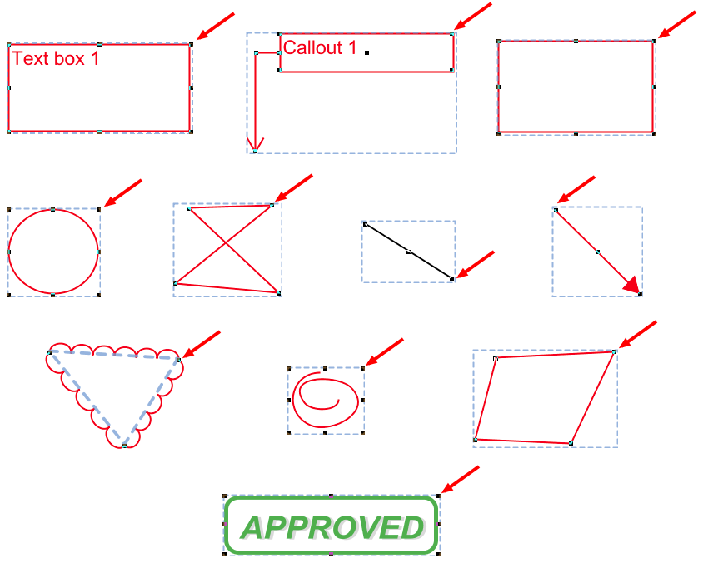

Deleting Annotations
Annotations on the page can be deleted using any of the below options

Delete a Specific Annotation:
- Using the Hand Tool or Object Selection Tool , Select the annotation that you wish to delete.
- Delete the annotation by pressing the Del key, click on the Delete button on the Mini Toolbar, or right-click on the annotation (CTRL + Click on Mac), choose "Delete" in the context menu.

Editing the Annotation Comment
An annotation's note can be edited by double-clicking directly on the annotation. This will display a small pop that will allow you to edit just the comment on the annotation. Type in the field to add, change, or delete the comment on the note. Once done click on the "x" or any where on the page to save the comment.
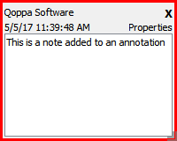

Annotation Properties Dialog
To access the annotation's full properties dialog right click (Mac: Ctrl + Click) on the annotation and choose Properties in the mouse menu or click on the edit button on the Mini Toolbar.
Each type of annotation has its own list of options. For a more detailed description of each of the annotation's available properties go to that specific annotation's page.
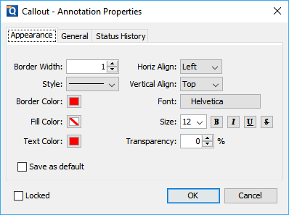

Property Dialog Tabs

Appearance
Where to edit all of the appearance settings of the annotation as well as the comment and default settings

General
Displays the author and subject information of the comment

Status History
This tab will display and changes to the review status of the annotation including Author, Status, and Timestamp. For more details see Setting Status or Check Marks on Annotations

Flattening Annotations
Flattening annotations is the act of painting the annotations directly on the page to which they belong so they are not editable anymore. This will permanently write an annotation into the document. For instance, a custom signature stamp can be flattened so the signature is added to the document itself and doesn't sit on a document as an annotation anymore.
Note: The following annotations (links, sounds, and redaction annotations) will NOT be removed when flattening annotations. Even though technically, links, sounds, and redaction annotations are annotations, they contain actions that would also be removed if the annotation was flattened and so they remain to not interfere with the functions placed in the PDF.

Flatten a Specific Annotation:
- Using the Hand Tool or Object Selection Tool , Select the annotation that you wish to flatten.
- Right-click on the annotation (CTRL + Click on Mac), choose "Flatten" in the context menu.
All annotations can be copied using Ctrl+C (Mac: Cmd+C) and pasted using Ctrl+V (Mac: Cmd+V) or by right clicking (Mac: Ctrl + Click) and selecting copy or paste. The copy command will copy any selected annotation to the system clipboard. If an annotation is in the system clipboard when the paste command is pressed, a copy of that annotation will be placed in the center of the screen. On subsequent pastes at the same location, the annotation will be pasted at a slight offset so that they are not placed directly on top of each other.

To paste an annotation onto a different page:
- Copy the annotation
- Navigate to the new page
- Click on the page with the mouse to select the page
- Paste the annotation using Ctrl+V (Mac: Cmd+V)

Pasting Clipboard Images as a Stamp
When an image is on the system clipboard, it can be pasted onto a page by following the steps below:
- Navigate to the page.
- Click on the page with the mouse to select the page.
- Paste the image using Ctrl+V (Mac: Cmd+V) onto the page. This will paste the image as a Rubber Stamp annotation that can be moved around or resized after it has been placed.

Pasting Clipboard Text as a Text Box
When text is on the system clipboard, it can be pasted onto a page by following the steps below:
- Navigate to the page.
- Click on the page with the mouse to select the page.
- Paste the text using Ctrl+V (Mac: Cmd+V) onto the page. Doing so will paste the text as a Text Box Annotation using default properties. The annotation can be moved around and resized after it has been placed.

Aligning Annotations
Annotations can be aligned or evenly distributed on the page if needed. Annotations can be aligned using any of the below methods. When aligning annotations 2 or more annotations must be selected.

From the Toolbar
- Using the Hand Tool or Object Selection Tool Select the annotations that you wish to align.
- Click the button on the toolbar to align the annotation

From Right Click Context Menu
- Using the Hand Tool or Object Selection Tool Select the annotations that you wish to align.
- Right click, (Mac: Ctrl + Click) on any of the selected annotations and go to Alignment and select the alignment you wish to perform

Alignment Examples
Original  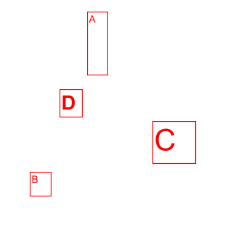 | Distribute Horizontally  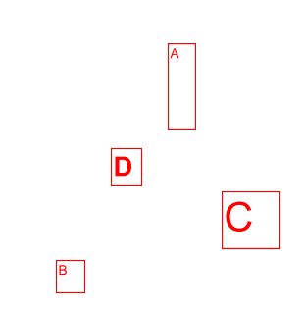 | Distribute  Vertically  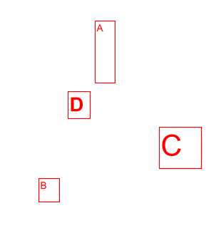
Align Left  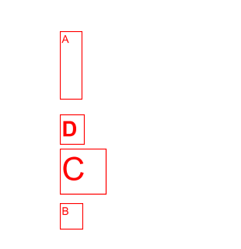 | Align Center  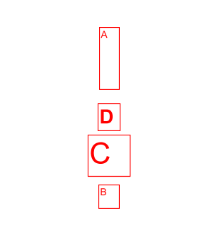 | Align Right  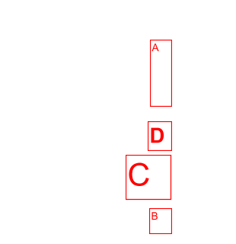
Align Top  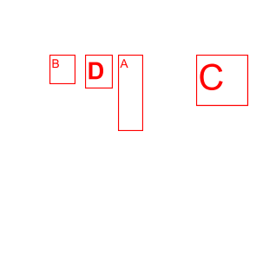 | Align Middle  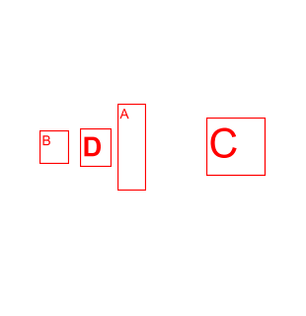 | Align Bottom  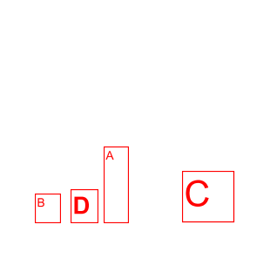
Align Width  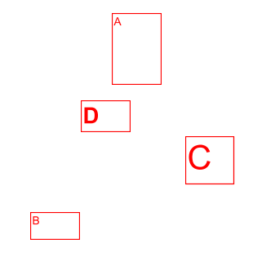 | Align Height  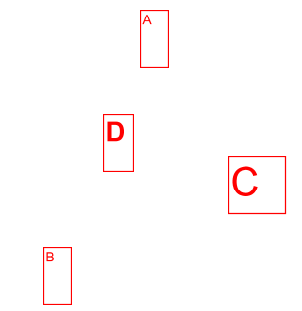 | Align Both  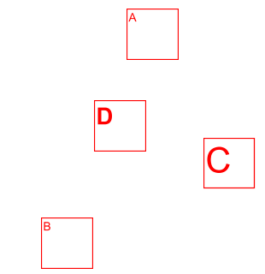

Group Annotations
A group of annotations is comprised of one parent annotation and one or more child annotations. Any operation (delete, move, etc.) performed upon one annotation in a group will also be performed on the rest of group. Also, all children will display their parent's comments.
Create a group by selecting two or more annotations, right-clicking (Mac: Ctrl+click) on one of them, and choosing Group from the mouse context menu. The annotation that was right-clicked will be the parent.
Annotations may be ungrouped by right-clicking (Mac: Ctrl+click) on an annotation group and choosing Ungroup from the mouse context menu.
Note: that the following annotations cannot be included in a group: sound and text replace annotations.

Assigning Comments to Layers
Comments can be assigned to a specific layer in the document. When the comment is associated with a layer showing or hiding the layer also affects the comments. You can edit the annotation properties to move comments to a new layer. Comments that are associated with No Layer will be a part of the primary PDF content.

Moving Comments to a New Layer
Existing comments can be moved to a new layer using the properties dialog
- Access the Comment properties by right clicking (Mac: Ctrl + Click) on the annotation and choosing Properties in the mouse menu or clicking on the edit button on the Mini Toolbar.
- Go to the General tab
- In the Layer option, select the layer you wish to move the annotation to
- Click OK to apply the changes
Note: If the layer selected is currently hidden the annotation will disappear until the layer is displayed again.

Setting Annotation Tool Properties
The tool's properties determine its default appearance and how the tool behaves after the annotation is created. The default properties can be accessed by right clicking (Mac: Ctrl+click) the tool icon in the toolbar.
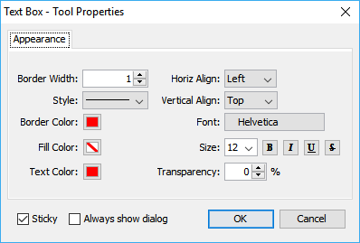

Appearance
Each type of annotation has its own list of options. For a more detailed description of each of the annotation's available properties go to that specific annotation's page.

Behavior
Sticky - When the tool is "sticky", the tool remains selected after a new annotation is added to the document until it is turned off. This allows you to place many annotations without having to reselect the tool. Once active click the button on the toolbar again to deactivate the tool.

After Creation Show
Determines whether the annotation properties dialog or popup note will be displayed after each new annotation is added to the document.

Setting a Status or Check mark
Setting the status or marking an annotation can be useful for keeping track of which annotations you have already reviewed. To set a status or checkmark, right click (Mac: Ctrl-Click) on the annotation and select Mark with Checkmark or select a status from the Review submenu.
The active annotation's checkmark can also be toggled in the Comments Pane with the Spacebar.
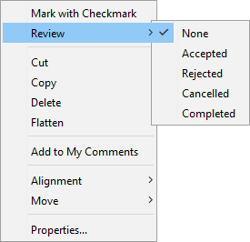
The review history is saved each time the annotation status is modified and can be viewed in the Status History tab on the Annotation Properties Dialog.

Comments Panel
The comments panel displays a list of all comments within the PDF document grouped by page. It provides an easy way to view and navigate comments within the document. The icon next to each comment will be displayed in the same color as the annotation displayed on the page.

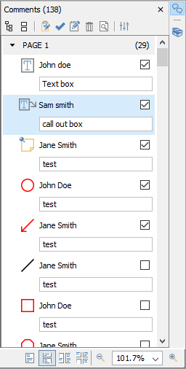

Accessing the Comments Panel
View the comments panel by clicking the comments button in the top right corner of PDF Studio. From this panel, you can view, search, and modify all the comments in the document.
The mouse is primarily used to navigate the comments panel. Clicking on any of the annotations listed will navigate the document to where the annotation is located on the page and select the current annotation. The following keyboard shortcuts can be used as well to navigate the comments panel.
- Arrow Keys - Up and Down can be used to navigate up and down the annotation list
- Spacebar - Highlight an annotation and press space bar to toggle the check box.
- Enter - Press Enter on a selected annotation to open the Note popup, then type the note you wish to add. Once complete press Esc to close the popup.

Comments Panel Toolbar
The following options are available at the top of the comments panel.
Expand: Expands the comment tree to show all pages and review markups
Collapse: Collapses the tree to only show the page folders
Status : Marks the selected annotation with a review status. See Setting Status or Check Marks
Properties: Opens the properties for the selected annotation(s)
Mark with Check Mark: Marks the selected annotation with a check mark. See Setting Status or Check Marks
Delete: Deletes the selected comment
Search: Enter text and press Enter to search for the text within the annotation comments
Previous Search Result: Goes to the previous search result
Next Search Result: Goes to the next search result
Filter: Allows you to filter out comments based on the following properties. Check the properties you wish to be shown and all annotations that do not have a property matching the selection will be hidden in the comments pane and on the page.
- All: Select the "All" option to restore showing all the annotations.
- Author: list of authors found in the document
- Type: list of annotation types found in the document
- Marked: list of marked annotations in the document
- Status: list of statuses found in the document
- Color: list of annotation colors found in the document
Options: Contains additional comment panel options
- Export: Export comments into a separate file.
  - FDF: File format created by Adobe that is supported by most PDF applications
  - XFDF: Extended FDF file format created by Adobe that is supported by most PDF applications
  - Text: Simple text file (.txt) that will contain all of the annotation information
  - XML: File format that is similar to an Excel file that will contain all of the annotation information
  - CSV: Exports all comment data into the .csv format allowing you to view in any spreadsheet editor such as Microsoft Excel
  - highlighted Text: Creates a plain text file with all highlighted text separated by pages.
- Print: Allows you to print the comments in the tree
  - Text: Prints just a simple text tree with all comments
  - Tree: Prints the entire tree exactly as it is displayed in the Comments Panel
- Hide All Comments: When checked will hide all the comments from being displayed
- View: turns on and off individual details displayed in the comments panel

Exporting Annotations
Comments can be exported from the current document into a file in FDF, XFDF, .txt. or XML format. Comments from Text Annotations, Graphics Annotations, and Sound Annotations will be exported. Hyperlinks are not considered comments in PDF format and thus are not exported.
Comments can be exported in the following formats
FDF: File format created by Adobe that is supported by most PDF applications
XFDF: Extended FDF file format created by Adobe that is supported by most PDF applications
Text: Simple text file (.txt) that will contain all of the annotation information
XML: File format that is similar to an Excel file that will contain all of the annotation information

How to Export Annotations
- Click on the Export button on the top right of the Comments Panel.
- Select whether to export in FDF, XFDF, Text, or XML format. This will display a save dialog.
- Select the location and name of the file to export to and click Save.
jPDFEditor comes with advanced tools to edit and manipulate PDF documents including content editing, redaction, modifying pages, and creating bookmarks.
Content Editing: Edit text, images, and content within the PDF
Redaction: Securely redact text and images from the PDF
Modifying PDF Pages: Edit pages including, appending, inserting, extracting, deleting, and more
Bookmarks: Create, edit, and delete bookmarks
The Content Editing tool allows you to edit existing content within a PDF. You can change the characteristics of text or content as well as move and delete image content as well.
Note: Annotations are not a part of the PDF content and so these cannot be edited by the Content Editing tool. To edit annotations see Editing Annotations.

Content that can be edited:
Only specific types of PDF content can be edited. Follow the links below on how to edit each type of content.
Text Content: Edit text contained within the PDF
Image Content: Edit images contained within the PDF
Path Content: Edit other objects which include lines and shapes within the PDF
Shade Content: Edit shade and gradient objects within the PDF

Using the Content Editing Tool
- Activate the tool by clicking on the Edit Content button
- Then click or drag an area with the mouse to select the desired content. Once selected, content can be moved, edited, or deleted.
- To exit the selection mode, simply click on the hand tool or Esc on the keyboard.

Editing Text Content
The Content editing tool is capable of editing text that is a part of the PDF. Text can be moved, edited, deleted, or redacted using the content editing tool.
Note: Not all text displayed in a PDF is considered text content. In some cases the text may actually be an image or even path objects. Text content that is either a path or image will not function the same and have limited editing abilities.

How to Edit Text Content
- Activate the tool by clicking on the Edit Content button on the Toolbar
- Then click or drag an area with the mouse to select the desired content. Once selected, content can be edited, moved or deleted following the instructions below.
  - Note:Selecting multiple pieces of content will let you update the properties for all pieces at once
- Once complete, to exit Content Editing mode, simply click on the hand tool or Esc on the keyboard

Move or Edit Properties
Move or Edit the text by doing the following
- Move: Click on the text and drag it to its new location on the page.
- Edit: To access the Text properties, right click (Mac: Ctrl + Click) and choose Properties in the mouse menu or double click on the selected text.

Text Content Properties
Text Content contains the following property settings:
Font – choose a new font for the selected text from the list
Note: When choosing a font only fonts that are embedded in the document can be selected. In addition, if the font is subsetted not all of the font characters may be available and may show up as either an incorrect or missing character when editing the text.
Text Color – change the color of the text
Outline Color – add or adjust the outline of the text
Text Size – edit the font size
Outline Width – increase or decrease the width of the outline
Character Spacing – increase the space between each letter
Horizontal Scaling – increase or decrease the spacing between each letter
Word Spacing – increase the space between each word
Baseline Offset – move line of text above or below the surrounding text; create super- or sub-scripts
Text – change the wording of the text

Cut, Copy, & Paste Text Content
Cut or Copy text by doing the following
- Cut: Cut the Text by using the shortcut key Ctrl + X (Mac: Cmd + X) or right-click on the text (CTRL + Click on Mac) and choose Cut in the context menu.
- Copy: Copy the Text by using the shortcut key Ctrl + C (Mac: Cmd + C) or right-click on the text (CTRL + Click on Mac) and choose Copy in the context menu.
- Paste: Navigate to the location you wish to paste the text and use the shortcut key Ctrl + V (Mac: Cmd + V) or right click (Mac: Ctrl + Click) and select Paste in the context menu

Remove Text Content
Delete or Redact text by doing the following
- Delete: Delete the Text by pressing the Del key or right-click on the text (CTRL + Click on Mac) and choose Delete in the context menu.
- Redact: Redact the Text by right-click on the text (CTRL + Click on Mac) and choose Redact Text in the context menu.
Note: The Redact option in Content editing functions exactly the same as using the PDF Redaction and will completely remove the selected text and replace it with a black bar.

Editing Image Content
The Content editing tool is capable of editing images that are a part of the PDF. Images can be moved, deleted, or redacted using the content editing tool. The content editing tool can also change the compression, color space, and DPI of individual images within the document. Images from within the PDF can also be saved directly to your computer by using Save As which will allow you to choose a location to save the image to.
Note: Not all images displayed in a PDF are actually image content. In some cases the images may actually be many path objects combined together to form an image. Image content that is a path will not function the same and have limited editing abilities.

How to Edit Image Content
- Activate the tool by clicking on the Edit Content button on the Toolbar
- Then click or drag an area with the mouse to select the desired content. Once selected, content can be edited, moved or deleted following the instructions below.
  - Note:Selecting multiple pieces of content will let you update the properties for all pieces at once
- Once complete, to exit Content Editing mode, simply click on the hand tool or Esc on the keyboard

Move or Edit Properties
Move or Edit the image by doing the following
- Move: Click on the text and drag it to its new location on the page.
- Edit: To access the Image properties, right click (Mac: Ctrl + Click) and choose Properties in the mouse menu or double click on the selected image. Click on the "Edit" button to display the image editing options. Choose the options you wish to change for the selected image and click OK when done.
  - Note: Editing the image properties cannot be undone without reopening the original document. Make sure to select the settings appropriately.

Image Content Properties
Image Content contains the following property settings:
Color space: displays the color format details of the image
Compression type: displays the image compression format used for the image
DPI Resolution: displays the DPI (dots per inch) of the image
Dimensions: the dimensions of the image in pixels
Size: the file size of just the selected image

Edit Image Options
The following options are available when editing the image.
Compression: Convert any image to either a JPEG, JPEG2000, FLATE, or JBIG2.
JPEG - lossy compression that will reduce image quality and size
JPEG2000 - less lossy compression that will reduce size and some quality
FLATE - Lossless compression does not reduce quality but may not always reduce file size
JBIG2 - Lossless compression that can only support black and white color space. Color images will be converted to black and white. Best for scanned documents with no images
Quality: Allows the image quality to be adjusted between 10-100%.
This will only affect JPEG or JPEG2000 images as these are the only formats that support image quality settings.
Color Space: Choose to either retain or convert the image colors to Grayscale or B&W.
Grayscale - Only supported with JPEG, JPEG2000, or FLATE. Best for full color images
B&W - Only supported by FLATE or JBIG2. Best for scanned documents with no images
DPI: Adjust the image resolution of all images that are larger than the option selected
Preset options include retain, 50, 100, 150, 200, 300, & 600 DPI
Custom option allows user to set any value between 50-1200 DPI

Cut, Copy, & Paste Image Content
Cut or Copy image by doing the following
- Cut: Cut the image by using the shortcut key Ctrl + X (Mac: Cmd + X) or right-click on the text (CTRL + Click on Mac) and choose Cut in the context menu.
- Copy: Copy the image by using the shortcut key Ctrl + C (Mac: Cmd + C) or right-click on the text (CTRL + Click on Mac) and choose Copy in the context menu.
- Paste: Navigate to the location you wish to paste the image and use the shortcut key Ctrl + V (Mac: Cmd + V) or right click (Mac: Ctrl + Click) and select Paste in the context menu

Remove Image Content
Delete or Redact image by doing the following
- Delete: Delete the image by pressing the Del key or right-click on the text (CTRL + Click on Mac) and choose Delete in the context menu.
- Redact: Redact the image by right-click on the image (CTRL + Click on Mac) and choose Redact Text in the context menu.
Note: The Redact option in Content editing functions exactly the same as using the PDF Redaction and will completely remove the selected image and replace it with a black bar.

Save Images
- Select the image you wish to save to your computer and right-click (CTRL + Click on Mac) on the image and choose Save As.
  - Note:Only 1 image can be saved at a time.
- Select the location on your computer where you would like to save the image, choose a file name and an image format then click Save.
- Once complete, to exit Content Editing mode, simply click on the hand tool or Esc on the keyboard
You can use the Export All Images tool to save all the images within the document to your computer at once.

Editing Path Content
Path content is are lines and shape objects within the PDF. Paths are two-dimensional shapes created using a set of points to generate lines or shapes. Paths can be used to create anything from shapes and dividers to even text and images. The Content editing tool is capable of editing paths that are a part of the PDF. Paths can be moved, edited, or deleted using the content editing tool.

How to Edit Path Content
- Activate the tool by clicking on the Edit Content button on the Toolbar
- Then click or drag an area with the mouse to select the desired content. Once selected, content can be edited, moved or deleted following the instructions below.
  - Note:Selecting multiple pieces of content will let you update the properties for all pieces at once
- Once complete, to exit Content Editing mode, simply click on the hand tool or Esc on the keyboard

Move or Edit Properties
Move or Edit the path by doing the following
- Move: Click on the path and drag it to its new location on the page.
- Edit: To access the path properties, right click (Mac: Ctrl + Click) and choose Properties in the mouse menu or double click on the selected path.

Path Content Properties
Path Content contain the following property settings:
Fill Color: the fill color of the path
Stroke Color: the border color of the path
Border Width: the width of the border line of the path

Cut, Copy, & Paste Path Content
Cut or Copy path by doing the following
- Cut: Cut the path by using the shortcut key Ctrl + X (Mac: Cmd + X) or right-click on the path (CTRL + Click on Mac) and choose Cut in the context menu.
- Copy: Copy the path by using the shortcut key Ctrl + C (Mac: Cmd + C) or right-click on the path (CTRL + Click on Mac) and choose Copy in the context menu.
- Paste: Navigate to the location you wish to paste the path and use the shortcut key Ctrl + V (Mac: Cmd + V) or right click (Mac: Ctrl + Click) and select Paste in the context menu

Remove Path Content
Delete the path by pressing the Del key or right-click on the path (CTRL + Click on Mac) and choose Delete in the context menu.

Editing Shade Content
Shade content is very similar to shades except instead of a solid color fill a gradient or shade formula is used to create colors that gradually change across the shape. Shades can be used to create anything from shapes and dividers to even logos and images. The Content editing tool is capable of editing shades that are a part of the PDF. Shades can be moved, edited, or deleted using the content editing tool.

How to Edit Shade Content
- Activate the tool by clicking on the Edit Content button on the Toolbar
- Then click or drag an area with the mouse to select the desired content. Once selected, content can be edited, moved or deleted following the instructions below.
  - Note:Selecting multiple pieces of content will let you update the properties for all pieces at once
- Once complete, to exit Content Editing mode, simply click on the hand tool or Esc on the keyboard

Move or Edit Properties
Move or Edit the shade by doing the following
- Move: Click on the shade and drag it to its new location on the page.
- Edit: To access the shade properties, right click (Mac: Ctrl + Click) and choose Properties in the mouse menu or double click on the selected shade.

Shade Content Properties
Shade Content contain the following property settings:
Fill Color: the fill color of the shade
Stroke Color: the border color of the shade
Border Width: the width of the border line of the shade

Cut, Copy, & Paste Shade Content
Cut or Copy shade by doing the following
- Cut: Cut the shade by using the shortcut key Ctrl + X (Mac: Cmd + X) or right-click on the shade (CTRL + Click on Mac) and choose Cut in the context menu.
- Copy: Copy the shade by using the shortcut key Ctrl + C (Mac: Cmd + C) or right-click on the shade (CTRL + Click on Mac) and choose Copy in the context menu.
- Paste: Navigate to the location you wish to paste the shade and use the shortcut key Ctrl + V (Mac: Cmd + V) or right click (Mac: Ctrl + Click) and select Paste in the context menu

Remove Shade Content
Delete the shade by pressing the Del key or right-click on the shade (CTRL + Click on Mac) and choose Delete in the context menu.
The Redaction tool completely removes all traces of the redacted content from the document. Not only does it remove text but it is also capable of redacting partial and entire images.

What is Redaction?
PDF Redaction is when you remove any information from a document prior to publication or distribution. This is often necessary when you have confidential or private information that you do not want others to see or have access to but still want to make part of the document available. The most common example of this is a black rectangle covering portions of text.
It’s EXTREMELY important that when redacting text/objects from a document that it is done properly. Not all redactions are the same and if done incorrectly an individual can still retrieve the information. Take for example the text below, it appears that part of the text has been redacted and you don’t know what it is.
My bank account number is 123456789 and routing number is 654987.
If you use your cursor to highlight the above text you be able to easily see the text. Just covering the text with a black opaque highlight appears to have hidden the words but in reality the information is still there. Anyone can just copy and paste the information into any other document. The same also applies to attempting to cover up text with a Black Square Annotation. The text still exists beneath the annotation and can easily be accessed by deleting the annotation or extracting text.

Redaction Steps:
- Redaction Annotations: Adds redaction annotations to the document that offer a preview of what the document will look like after redaction, and also allows you to adjust Redaction Properties before being applied.
- Applying Redactions: This "burns in" the annotations and removes any text, image, or drawing from the document that is underneath the annotation's area.

Starting the Redaction Tool
- Activate the tool by clicking on the Redaction Tool button
- Then click or drag an area with the mouse to select the desired text, images, or areas you wish to redact.
- Once selected right click (Mac: Ctrl + Click) and choose Apply All Redactions in the mouse menu
- To exit the selection mode, simply click on the hand tool or Esc on the keyboard.

Redaction Annotations
The first step of redaction is to Add Redaction Annotations. Adding redaction annotations to the document provides a preview of what the document will look like after redaction, and also allows you to adjust redaction properties before being applied.
- Activate the tool by clicking on the Redaction Tool button
- Then click or drag an area with the mouse to select the desired text, images, or areas you wish to redact.
- Once selected right click (Mac: Ctrl + Click) and choose Apply All Redactions in the mouse menu
- To exit the selection mode, simply click on the hand tool or Esc on the keyboard.
Note: When the mouse pointer is a cursor, you can select text to be redacted. When the pointer is a plus sign, you can drag a rectangle to encompass sections of images, drawings, and text in the area.
Cursor selection | Rectangle selection
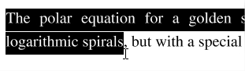 | 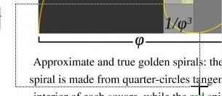

How to Create Redaction Annotations
You can securely redact PDF Documents in jPDF Editor by following the directions below. It’s important that you complete all the steps listed below in order to ensure your document is properly redacted. The Redaction tool only removes PDF Content.

Redaction Steps
- Activate the tool by clicking on the Redaction Tool button
- Begin marking the content that you wish to be redacted. This can be done in 3 different ways:
  - Text: Text can be marked for redaction by using the cursor to highlight the text you wish to be redacted.
  - Other Objects/Images: Other objects that cannot be selected (for example: images, scanned text, paths) can be marked for redaction by using Ctrl + Click (Command + Click on Mac) and dragging to create a box over the content you would like redacted.
  - Alternate Selection Method: Double click on a word or image to highlight just that word or image for redaction.
- Each of the items that you mark for redaction will show a transparent black box with a red outline. IMPORTANT: The text has not yet been redacted. These marks are just there as an indication of what will be redacted and allows you to verify what will be removed prior to redaction.
- **EXTREMELY IMPORTANT** Once you have completed marking all of your items for redaction you then need to actually redact the content from the document. You can do so by right clicking (CTRL + Click on Mac) on any marked redaction and selecting Apply All Redactions.
- Once complete, to exit the Redaction Tool, simply click on the hand tool or Esc on the keyboard

Redaction Properties
When redacting content from within the PDF there are a variety of options that can be set. These options can apply to either the redaction annotation or the redaction once applied.

Redaction Annotation Properties
To access the Redaction Annotation properties right click (Mac: Ctrl + Click) on the redaction annotation and choose Properties in the mouse menu or click on the edit button on the Mini Toolbar. Redaction Annotations contain the following property settings.

Appearance

Annotation
Outline Color - Sets the color of the border for only the redaction annotation
Fill Color - Sets the fill color for only the redaction annotation
Transparency - Sets the transparency of the shape for only the redaction annotation

Redaction
Fill Color - Sets the fill color of the redaction once it is applied
Note: Selecting the No Color option erases the content and will not place any square where the content used to be once the redaction has been applied.
Text - This will apply text on top of the redaction square once applied
Font - The font of the text placed on top of the redaction
Font Size - The font size of the text placed on top of the redaction
Font Color - The color of the text placed on top of the redaction
Alignment - The alignment of the text placed on top of the redaction
Repeat Text - Weather or not to continuously repeat the text placed on top of the redaction
Note / Comment - A note can be added to shapes that will be displayed when hovered over by the mouse
Save as default - When checked this will make the selected appearance settings the default for any new Redaction annotations going forward
Locked - When checked prevents the following on the annotation: being moved or resized, editing appearance properties, & deleting the annotation.

General
Author - Allows you to edit the author
Subject - Allows you to edit the subject

Status History
This tab will display and changes to the review status of the annotation including Author, Status, and Timestamp. For more details see Setting Status or Check Marks on Annotations

Applying Redactions
Applying the redaction is an important step to ensure that the selected content will actually be removed. This "burns in" the annotations and removes any text, image, or drawing from the document that is underneath the annotation's area.

Applying Redactions
To complete the redaction process after the Redaction Annotations have been applied, follow the steps below.
- Right click (CTRL + Click on Mac) on any marked redaction and selecting Apply All Redactions.
- The document is now redacted and all of the marked items will now be solid black squares (unless a different color option was selected in Redaction Properties).
- Make sure to save your document. If you would like to confirm that the document is in fact redacted you can confirm by following the steps listed below.
- Once complete, to exit the Redaction Tool, simply click on the hand tool or Esc on the keyboard

Checking if Your PDF Document is Redacted Correctly
You can check if your document was redacted correctly in jPDF Editor by using the Text Selection, Text Search, and Content Editor tool to see if you can select any of the content that you were trying to redact.

Using the Text Selection Tool
- Open the Redacted PDF Document you wish to check
- Using the Text Selection Tool highlight the line of text that contains the redacted words
- Copy the highlighted text to your clipboard by using the shortcut keys CTRL + C (Command + C on a Mac)
- Open up any text editor (Word, Notepad, Text Edit, etc…)
- Paste the text you highlighted using CTRL + V (Command + V on a Mac)
- If you redacted correctly then only the non redacted text should be displayed. If you see the text you were trying to remove than it was not done correctly.

Using the Text Search Tool
- Open the Redacted PDF Document you wish to check
- Open the Text Search Tool by clicking on the Text Search button on the toolbar, pressing Ctrl-F (Cmd + F on Mac)
- Type in the word you redacted and click on New Search
- This will bring up a list of all the text matching what you typed in the search box. Once the results appear you can click on each of the results to see where in the document that text is located.
- If you redacted correctly then only the non redacted text should be displayed and highlighted in the search results. If you see the text you were trying to remove than it was not done correctly.

Using the Content Editor
- Open the Redacted PDF Document you wish to check
- Start the Content Edit tool by clicking on the Edit Content button
- Select any of the redaction boxes on your document by clicking on it and then either move or delete the box.
- If you redacted correctly then nothing should remain under where the redaction box was. If you see the text you were trying to remove than it was not done correctly.
Note: When redacting part or all of an image sometimes the redaction square will become a part of the image and you will not be able to move or delete the actual square. During the redaction process if an image does not have a transparency value the removed data will just be converted to a solid black color. As long as the black square is now a part of the image and moves with the image it is properly redacted.
jPDFEditor has the following options available to modify pages within a PDF document.
Appending Document – Append another PDF document to the current one.
Inserting Pages – Insert pages from another PDF document into the current one.
Extracting Pages – Extract pages from the current document into a new document.
Deleting Pages – Delete pages from the current document.
Rotating Pages – Rotate pages in the current document.
Cut, Copy, and Paste Pages - Cut/Copy and Paste pages within a document or across documents.
Importing Images as Pages - Takes a selected image and inserts the image as a page within the PDF

Appending Documents
jPDFEditor can append other PDF documents to the end of a PDF. This is useful when combining multiple PDFs into a single document. Documents can be appended by dragging files directly onto the Thumbnail Pane directly.

Using Drag & Drop
Use the mouse to select thumbnail page(s) from the thumbnail pane and then:
- Copy - Select and drag thumbnail pages from the source document to the destination document's Thumbnail pane of the second document.
- Move - Select thumbnail pages from the source document. While holding Ctrl, drag the pages to the desired location within the Thumbnail Pane of the second document.

Inserting Pages
jPDFEditor can insert other PDF documents to a location you specify within the PDF. This is useful when combining multiple PDFs into a single document and the document's pages need to be inserted at a specific location. You can insert pages from another PDF document by opening it and dragging the thumbnails of the desired pages into the current document.

Using Drag & Drop
Use the mouse to select thumbnail page(s) from the thumbnail pane and then:
- Copy - Select and drag thumbnail pages from the source document to the destination document's Thumbnail pane of the second document.
- Move - Select thumbnail pages from the source document. While holding Ctrl, drag the pages to the desired location within the Thumbnail Pane of the second document.

Extracting Pages
jPDFEditor can extract pages from a PDF to a new PDF. This is useful if you need to separate a section of a PDF into a separate document. You can also extract pages by selecting the thumbnails of the desired pages you wish to extract and then dragging the selected pages outside of jPDF Editor and into a folder or on your desktop.

Using Drag & Drop
Use the mouse to select thumbnail page(s) from the thumbnail pane and then:
- Copy - Select and drag thumbnail pages from the document to a folder or on your desktop.
- Move - Select thumbnail pages from the source document. While holding Ctrl, drag the pages to a folder or on your desktop.

Deleting Pages
jPDFEditor can delete pages from within a PDF document. This can be done using the thumbnail pane.

Using the Page Thumbnails
In the page thumbnails pane select either a single or group of the pages you wish to delete then:
- Press the Del key on the keyboard
- Right click (Mac: Ctrl+Click) on any of the selected pages and then click "Delete Pages"

Rotating Pages
jPDFEditor can rotate multiple pages of a document at once. This is useful if the document was scanned upside down or is currently being displayed in the wrong direction. Pages can only be rotated in 90 degree increments.
Note: Rotating Pages is different then Rotating Page View in that it is not temporary and the changes made using this tool will permanently rotate the pages within the document when saved.

Using the Page Thumbnails

Using the Page Rotation Buttons
- In the page thumbnails pane select either a single or group of the pages you wish to rotate
- At the top of the thumbnails pane click on one of the icons to rotate the page
Rotate Clockwise: Rotates the pages 90 degrees (1/4 turn) to the right
Rotate Counterclockwise: Rotates the pages 90 degrees (1/4 turn) to the left

Using the Right Click Menu
- In the page thumbnails pane select either a single or group of the pages you wish to rotate
- Right click (Mac: Ctrl+Click) on any of the selected pages and then highlight "Rotate Pages". You will have the following 3 options available
  - Clockwise 90 degrees: Rotates the pages 90 degrees (1/4 turn) to the right
  - 180 degrees: rotates the pages 180 degrees
  - Counterclockwise 90 degrees: Rotates the pages 90 degrees (1/4 turn) to the left
- Click on the option you want to rotate the selected pages
Note: This will update the rotation property for the pages rotated in the document itself and the rotation will be saved when the document is saved. To rotate pages temporarily in the current view only, use the Rotate Clockwise and Rotate Counterclockwise buttons on the Toolbar.

Move, Cut, Copy, & Paste Pages
You can use the page thumbnails in the thumbnails pane to copy or move pages within a document or between different documents.
When you drag a page thumbnail in the page thumbnails pane, a bar appears between other page thumbnails, indicating the position in which the page will be moved to.

Within a PDF, using the Page Thumbnails
Use the mouse to select thumbnail page(s) from the thumbnail pane and then:

Using Drag and Drop
- Move - Select and drag thumbnail pages to the desired location within the Thumbnail Pane.

Using Right Click (Mac: Ctrl+Click)
- Copy - Right click (Mac: Ctrl+Click) or use keyboard shortcuts to copy the selected pages.
- Move - Right click (Mac: Ctrl+Click) or use keyboard shortcuts to cut the selected pages.
- Paste - Right click (Mac: Ctrl+Click) or use keyboard shortcuts to paste the copied or cut pages in the same document.

Import Images as Pages
jPDFEditor can import an image directly into the PDF as a page. This can be useful when adding scanned pages or charts to a document for example. The following image types can be imported: *png, *jpg, *jpeg, *jpe, *gif, *tif & *tiff.

Using Drag & Drop
Use the mouse to select the image(s) from a folder or your desktop and then drag them directly into the thumbnail pane of the document to have them converted into a page.
jPDFEditor has the following options available to create, edit, or manage bookmarks within a PDF.
Creating Bookmarks: how to create bookmarks in a PDF
Deleting Bookmarks: how to delete bookmarks in a PDF
Moving Bookmarks: how to move or rearrange bookmarks in a PDF
Bookmarking Selected Text: add a bookmark for the currently selected text
Renaming a Bookmark: editing or changing a bookmarks name
Set Bookmark Destination: set the destination of the bookmark when clicked
Editing Bookmark Actions: edit the actions associated with bookmarks
Custom Bookmark Actions: a list of all the available actions that can be set on bookmarks
Editing Bookmark Appearance : edit the appearance of bookmarks

Creating Bookmarks
jPDFEditor is able to create bookmarks in a PDF. This is useful when creating a table of contents or list of shortcuts to specific sections within the PDF. Typically a bookmark will only have one action associated with it and will be a Go To Page action. However, in the PDF format definition, bookmarks can have many different Bookmark Actions associated with them.

How to Create Bookmarks
Bookmarks may be added as parents or as children to existing bookmarks. In both cases, the new bookmark is added as a Go To Page action for the current page view (the current page number, magnification, and scrollbar values). Clicking on a bookmark will move to the bookmarked page and the scrollbars and scale are also set as they were when the bookmark was created.
Note: If any text is selected on the document, it will be used as the name of the bookmark. If not, the bookmark name will be based on the page number.

Create Bookmark as a Parent
To add a bookmark as a parent do one of the following:
- Go to Document > Create Bookmark, or use the shortcut key Ctrl + B (Command + B on Mac)
- Click the add bookmark button at the top of the bookmark panel

  - Note:If the bookmark panel is not visible (this happens when a document doesn't have any bookmarks defined), click onView > Bookmarksto display the bookmarks pane.
- Right click on an existing bookmark and go toAddin the right click menu and selectBeforeorAfter

Create Bookmark as a Child (under a parent)
To create a bookmark as a child (underneath or a subgroup of the parent)
- Right click (Mac: Ctrl + Click) on an existing bookmark and go toAddin the right click menu and selectChild

Bookmark Properties
To access the bookmark properties right click (Mac: Ctrl + Click) on the bookmark and choose Properties in the mouse menu. Bookmarks contain the following property settings.

Action
Bookmark Title - this is the label for the bookmark that will be displayed in the bookmarks pane
Bookmark Actions - After creation the bookmark's actions can be modified using this section. See Editing Bookmark Actions for a complete list of the available actions.

Appearance
Text Color - Sets the text color
Font Style - Sets the bookmark font to be either Bold or Italic
B - Makes all of the text Bold
I - Makes all of the text Italic
Save as default - When checked this will make the selected appearance settings the default for any new bookmarks going forward

Deleting Bookmarks
jPDFEditor is able to delete existing or created bookmarks from a PDF.

How to Delete Bookmarks
There are three ways that a bookmark can be deleted:
- Select the bookmark with the mouse and press Delete on your keyboard
- Select the bookmark with the mouse and click on the delete button at the top of the bookmark panel
- Right-click (Mac: Ctrl + Click) on the bookmark in the bookmark tree and choose the Delete option in the mouse menu
Note: Hold down SHIFT or CTRL (Command on Mac) to edit multiple bookmarks.

Moving Bookmarks
jPDFEditor can be used to move and reorganize bookmarks within the PDF document.

How to Move Bookmarks
Bookmarks can be moved using either drag and drop or by using the cut and paste functions.
Note: Hold down SHIFT or CTRL (Command on Mac) to edit multiple bookmarks.

Using Drag and Drop
Bookmarks can be reorganized simply by dragging and dropping them to the desired location in the tree. When a bookmark is dragged to a target, a horizontal black line appears on the screen under the target bookmark. The length of the black line indicates whether the dragged bookmark will be inserted underneath the target bookmark, or added as a child to the target bookmark.
This bookmark will become a child of Page 6.  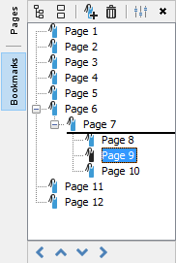  The longer line designates the bookmark will be inserted underneath page 7 | This bookmark will become a child of Page 7.  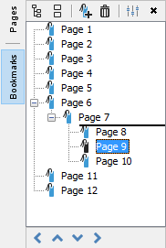  The shorter line designates that the bookmark will be added as a child of page 7

Using Toolbar Buttons
Bookmarks can also be moved by using the buttons located at the bottom of the bookmarks pane. Multiple bookmarks can be selected at once when moving them using the buttons.
Note: The buttons will only be enabled when the bookmark is able to be moved
Left - Moves the selected bookmarks to the left making it a parent bookmark
Up - Moves the bookmark up so it's before the one above it
Down - Moves the bookmark down so it's after the one below it
Right - Moves the bookmark to the right making it a child of the bookmark above it

Using Cut & Paste
Cut and Paste can also be used to reorganize bookmarks. You can cut a bookmark from the tree by right-clicking (Mac: Ctrl + Click) on it and selecting cut or by using the keyboard shortcut, Ctrl+X (Mac: Cmd + C). Then paste the bookmark onto its new parent by right-clicking (Mac: Ctrl + Click) on an existent bookmark and selecting Paste or by using the keyboard shortcut, Ctrl+V (Mac: Cmd + V).

Bookmarking Selected Text
If a bookmark is created while some text is selected in a document, the bookmark will be created for the current page view and the selected text will be used as its name.

How to Create a Bookmark from Selected Text
- Click on the Select Text icon on the toolbar
- Drag the mouse to select the desired text
- Once you have the word or text selected, create the bookmark using one of the methods below:

Create Bookmark from Text as a Parent
To add a bookmark as a parent do one of the following:
- Click the add bookmark button at the top of the bookmark panel
- Right click on an existing bookmark and go toAddin the right click menu and selectBeforeorAfter

Create Bookmark from Text as a Child (under a parent)
To create a bookmark as a child (underneath or a subgroup of the parent)
- Right click (Mac: Ctrl + Click) on an existing bookmark and go toAddin the right click menu and selectChild

Renaming Bookmarks
By default the bookmark name will either be the page number which may not be as useful to the reader. Bookmarks can be renamed after creation so the reader can understand exactly where it will lead them.

How to rename a Bookmark
Bookmarks can be renamed using one of the following methods below:
- Double-click on the bookmark in the bookmark tree and the bookmark label will become editable. Enter the new name for the bookmark then to save the new name press Enter or click somewhere else
- Right-click (Mac: Ctrl + Click) on the bookmark in the bookmark tree and select the Rename option in the mouse menu and enter a new name.

Setting Bookmark Destination
A bookmarks destination is where the user will be taken within the document when clicked. By default this will be the exact same view and scale set when the bookmark was created. The destination can easily be changed if needed after being created.

How to Set a Bookmark Destination
A bookmark's destination can be changed using one of the following methods below:

Using Set Destination
- Navigate to the location in the document that you want the bookmark to go to
- Then Right-click (Mac: Ctrl + Click) on the bookmark in the bookmark tree and select Set Destination.
  - Note: This will remove any actions currently associated with the bookmark and replace them with a Go To Page action for the current page and view.

Using the Properties Dialog
- Right click (Mac: Ctrl + Click) on the bookmark you wish to edit and choose Properties in the mouse menu.
- Click on the Edit button below the Bookmark Actions section
- Enter the details for the destination you would like the bookmark to go to
  - Page Number: the page number in the document
  - Zoom: the zoom to use if needed

    - Percent: only available if Custom is selected in Zoom
  - Set Visually: This allows you to set the destination by navigating to a point in the document. Once set the bookmark will go to the exact location and zoom level in the document that is set when using this function.

Editing Bookmark Actions
When a bookmark is created it will typically only have one action associated with it and that is the Go To Page action. However, in the PDF format definition, bookmarks can have many different Bookmark Actions associated with them. When adding a bookmark to a PDF document Custom Bookmark Actions can be created instead of the standard Go To Page action.
Note: If a bookmark has multiple actions associated with it, actions will be executed in the order they were added to the bookmark.

Modifying Bookmark Actions
Actions can be added, edited, and removed from a bookmark by following the instructions below

Adding Bookmark Actions
New actions can be added to a bookmark
- Right click (Mac: Ctrl + Click) on the bookmark you wish to add an action to and choose Properties in the mouse menu.
- The Action tab will display a list of actions currently associated with the bookmark.
- Click on the Add button below the Bookmark Actions section
- The Action Dialog will be displayed where the Custom Bookmark Actions can be set for the bookmark
- Once complete click OK on the Action dialog and OK again to save the action

Editing Bookmark Actions
Existing actions in a bookmark can be edited
- Right click (Mac: Ctrl + Click) on the bookmark you wish to edit and choose Properties in the mouse menu.
- The Action tab will display a list of actions currently associated with the bookmark.
- Click on the Edit button below the Bookmark Actions section
- The Action Dialog will be displayed showing the properties for the currently selected action
- Make the changes needed to the action
- Once complete click OK on the Action dialog and OK again to save the action

Removing Bookmark Actions
Existing actions in a bookmark can be removed
- Right click (Mac: Ctrl + Click) on the bookmark you wish to remove and choose Properties in the mouse menu.
- The Action tab will display a list of actions currently associated with the bookmark.
- Click on the Remove button below the Bookmark Actions section to delete the action from the bookmark
- Once complete click OK to save the changes
  - Note:It is possible to have a bookmark with no actions set.

Custom Bookmark Actions
Below is a list of the each of the custom bookmark actions and their settings.

Go to a page in this document
Sets the bookmark to go to a page within the current document
- Page Number - the page number of the document to bookmark to
- Zoom - Set the page fit when navigating to the page
- Percent - The zoom level for Custom zoom setting
- Set Visually - Allows you to set the location of the bookmark visually

Go to a page in another document
Sets the bookmark to go to a page within a different designated document
- Page Number - the page number of the document to bookmark to
- Document - The full path to the document to open. Click on the "..." button to open a file chooser and navigate to the file you wish to select.
Note: When sending this document to other users this action may not work if the file is not in the same location on the users computer. To make sure the file is included with the PDF when sending to another user try using a File Attachment instead.

Show/Hide Fields
Sets the bookmark to either Show or Hide selected fields within the document
- Show - Will show the selected fields when clicked
- Hide - Will hide the selected fields when clicked
- Field List - Displays a list of the fields in the document to select. To select more than one field use Ctrl + Click (Command + Click for Mac) to select separate fields or Shift + Click to select a group of fields

Open File
Sets the bookmark to open a specific file.
- File - The full path to the file to open. Click on the "..." button to open a file chooser and navigate to the file you wish to select.
Note: When sending this document to other users this action may not work if the file is not in the same location on the users computer. To make sure the file is included with the PDF when sending to another user try using a File Attachment instead.

Open a web link
Set's the bookmark to open a specific web page or start an email. Examples of valid links:
- http://www.qoppa.com
- ftp://ftp.site.com
- file:c:\qoppa\temp.txt
- mailto:johndoe@gmail.com

Reset Form Fields
Sets the bookmark to reset the selected fields within the document
- All Fields - When checked will reset all the fields within the document
- Field List - Displays a list of the fields in the document to select. To select more than one field use Ctrl + Click (Command + Click for Mac) to select separate fields or Shift + Click to select a group of fields

JavaScript Action
Sets the bookmark to perform a custom Supported JavaScript action that can be typed into the field.

Submit Form
Sets the bookmark to send the form field values to a designated location in one of 4 formats. This can be used to have an automatic way to send back forms or values once a user has completed the form.
- URL - The destination to send the selected file to. Examples of valid links:

  - http://www.qoppa.com
  - ftp://ftp.site.com
  - file:c:\qoppa\temp.txt
  - mailto:johndoe@gmail.com
- FDF - Sends an FDF file containing the selected field values
- XFDF - Sends an XFDF file containing the selected field values
- PDF - Sends a copy of the entire PDF
- HTML - Sends an HTML file containing the selected field values
- Fields - Sets the options when sending the field values

  - All Fields - Will send all fields regardless of value
  - Include - Will include the selected fields in the list when sending the file
  - Exclude - Will exclude the selected fields in the list when sending the file
  - Field List - Displays a list of the fields in the document to select. To select more than one field use Ctrl + Click (Command + Click for Mac) to select separate fields or Shift + Click to select a group of fields
  - Send Empty Fields - When checked will send the selected fields values even when fields are empty

Show/Hide Layers
Sets the bookmark to either Show or Hide selected layers within the document
- Use Current Visibility - Sets the action to display the layers as they are currently being displayed so that if layers are turned off later they will return to the current state
- Other - Sets a new action for the layer using the blow options

  - Show - Will show the selected layers in the list
  - Hide - Will hide the selected layers in the list
  - Toggle - Will switch the selected layer(s) state from hidden to displayed or displayed to hidden depending on the layers current state
  - Layers List - Displays a list of the layers in the document to select. To select more than one layer use Ctrl + Click (Command + Click for Mac) to select separate layers or Shift + Click to select a group of layers

Named Action
Sets the bookmark to perform one of standard predefined actions listed below.
- NextPage - Goes to the next page in the document
- PrevPage - Goes to the previous page in the document
- FirstPage - Goes to the first page in the document
- LastPage - Goes to the last page in the document
- Print - Starts the print dialog to print the current document
- Save - Saves the current document
- Open - Displays the open file dialog

Editing Bookmark Appearance
A bookmark's appearance can be edited to give the text a different color or style. This can be used when organizing the bookmarks to highlight or color code topics

How to Edit a Bookmark's Appearance
- Right-click (Mac: Ctrl + Click) on the bookmark in the bookmark tree and select the Properties option in the mouse menu.
  - Note:Hold down SHIFT or CTRL (Command on Mac) to edit multiple bookmarks.
- Then go to the Appearance tab and set the below settings
- Once complete click OK to save the changes

Appearance Settings
Text Color - Sets the text color
Font Style - Sets the bookmark font to be either Bold or Italic
B - Makes all of the text Bold
I - Makes all of the text Italic
Save as default - When checked this will make the selected appearance settings the default for any new bookmarks going forward
jPDFEditor supports standard form fields in PDF documents and allows you to edit and fill out PDF forms in PDF documents.
Filling PDF Forms: Filling and completing existing PDF forms
Exporting PDF Form Data: Exporting form field data from PDFs
Importing PDF Form Data: Importing form field data into PDFs
Resetting Form Fields: Resetting existing PDF form fields to their default values
PDF Form JavaScript: Custom JavaScript actions that are supported in form fields

Filling PDF Forms
jPDFEditor can be used to fill and complete existing interactive form fields within a PDF. Once complete the form can be printed or saved just as any other PDF document.
Note: To fill a non-interactive form, when the form is simply a scanned page and there are no active fields on it, you can use the Typewriter Tool.

How to fill PDF form Fields
To fill a PDF interactive form, simply open the document by clicking File -> Open and fill the forms using the instructions for each field type below. Use the Tab key to navigate to the next field and Shift + Tab to go to the previous field. To save all of the data entered into the PDF form, simply save the PDF document by going to File -> Save or clicking on the save button .
Note: LiveCycle XFA forms – also called dynamic XFA forms – are not supported in jPDF Editor.
The following form field types are supported in jPDF Editor:
Text Fields | Allows you to enter text into the field. In some cases there may be formatting rules in place that will only allow you to enter a specific type of information. For example: time or date fields. | 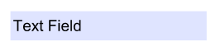
Check Boxes | Can either be checked or unchecked. Multiple check boxes can be checked at once. | 
Radio Buttons | Similar to a check box except radio buttons belong to groups and so only one button in each group can be checked at a time | 
Combo Boxes | A drop down menu that displays a list of choices. Click on the down arrow to display the list of available options. In some cases this field will also allow custom text to be entered | 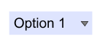
List Box | Displays a list of multiple choice items in a box that can be selected. In some cases the field will also allow multiple items to be selected at once. To select more than one item at a time, hold down Ctrl or Shift and click on each of the options. | 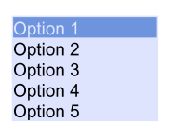
Buttons | Performs an action when clicked | 
Signature Fields | A designated location to apply a  Digital Signature  to the document. Click on the field to place a signature | 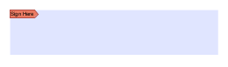

Exporting Form Data
Form data can be exported from the current document into a file in FDF, XFDF, XDP, or XML formats. Form field data from all Form Field Types will be exported during this process.
Forms can be exported in the following formats
FDF: File format created by Adobe that is supported by most PDF applications
XFDF: Extended FDF file format created by Adobe that is supported by most PDF applications
XDP: An XML Data package created by Adobe that is supported by most PDF applications
XML: File format that is similar to an Excel file that will contain all of the annotation information

How to Export Form Data
Note: "To perform this function see the specific documentation for your application for detailed instructions"

Importing Form Data
Form field data can be imported from either an FDF, XFDF, or XDP file into the current document. Any form data from any of the Form Field Types will be imported.
Note: Form data can only be imported into the exact same form as it was exported from meaning that both the field type and name have to be exactly the same in order for the data to be imported.
Comments can be imported using the following formats
FDF: File format created by Adobe that is supported by most PDF applications
XFDF: Extended FDF file format created by Adobe that is supported by most PDF applications
XDP: An XML Data package created by Adobe that is supported by most PDF applications

How to Export Annotations
Note: "To perform this function see the specific documentation for your application for detailed instructions"

Resetting Form Fields
Reset Form Fields will reset the data in all fields in the form. When resetting a field, data will be set to the field's default value or to null if the field has no default value.

How to Reset Form Field Values
Note: "To perform this function see the specific documentation for your application for detailed instructions"

PDF Form JavaScript
In jPDFEditor when creating custom functions/actions for specific items such as form fields or buttons you will need to use JavaScript for the commands. JavaScript can perform calculations, button actions (adding images, submitting forms, or populating other fields), validate field input, and set field formatting, among many other things.
Note: jPDFEditor only supports Acroform (non-LiveCycle) JavaScript in PDF forms.
You will need to have advance knowledge in programming JavaScript in order to create the actions for the buttons. For additional details on how to use these functions, take a look at the tutorials and lessons on this site http://www.w3schools.com/js/js_intro.asp
jPDFEditor supports the following JavaScript commands for each of the below items.

Supported JavaScript

Document

Methods:
addField
calculateNow
getAnnots3D
getField
getNthFieldName
getOCGs
resetForm

Properties:
calculate
numFields
numPages
URL

Fields

Methods:
buttonGetCaption
buttonImportIcon
buttonSetCaption
checkThisBox
clearItems
deleteItemAt
getArray
getItemAt
insertItemAt
isBoxChecked
setAction
setFocus
setItems

Properties:
borderColor
borderStyle
borderWidth
calcOrderIndex
charLimit
comb
commitOnSelChange
currentValueIndices
defaultValue
delay
display
doc
doNotScroll
doNotSpellCheck
editable
exportValues
fileSelect
fillColor
hidden
lineWidth
multiline
multipleSelection
name
numItems
page
password
readonly
required
strokeColor
style
submitName
textColor
type
userName
value
valueAsString

Global

Methods:
setPersistent

OCG

Methods:
getIntent
setAction
setIntent

Properties:
initState
locked
name
state

Utilities

Methods:
printd
printf
printx
jPDFEditor supports both adding a digital signature field to a PDF or applying digital signatures to existing fields. Digital Signatures are a way of authenticating the contents of a document. A document with a valid signature is guaranteed not to have been changed since being signed.
Create Digital Signature Fields : Create new unsigned digital signature fields
Modifying Digital Signature Fields : Modify existing field including clearing, moving, and properties
Applying Digital Signatures : How to apply digital signatures to a document
Validate Digital Signatures : How to validate a digital signature

Creating Digital Signature Fields
jPDFEditor can create new, unsigned digital signature fields in a document. This is can be used to create a document that requires a signature and to add a signature field so that a digital signature can be applied.
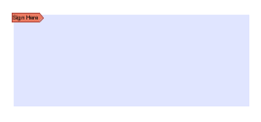

How to Create a Digital Signature Field
- Open a document to add a digital signature field to
- Click on the Digital Signature button on the toolbar
- When the tool is started, the cursor will become a crosshair to mark the location for the new field on the document. Drag a rectangle to create the desired signature field size
- After the field is created, the field can be clicked on to apply a digital signature.

Modifying Digital Signature Fields
Signature fields can be modified using any of the available options below. The options will vary depending on whether the digital signature field has been signed.
To access the digital signature field options Right Click (Ctrl + Click on Mac) on the field and then a mouse context menu will be displayed showing the available options. Any text that has been greyed out is a disabled option.

Unsigned Digital Signature Fields
The Following options are available for an unsigned digital signature field.
Apply Signature - Starts the Applying Digital Signatures dialog
Apply Certifying Signature - Starts the Applying Digital Signatures dialog except with the certifying signature option already selected
Move - Allows you to move or resize the unsigned field on the page. When finished click anywhere on the page or press Esc to finish editing.
- Move: click on the signature field and drag it to its new location on the page.
- Resize: use the black dots on the corners and edges to resize the shape of the box so that it fits the area that you need.
Delete - Deletes the selected signature field
Details - Displays the details for the signature field.
Note: When unsigned this will just display a "Signature field has not been signed" message as there are no details to display.

Signed Digital Signature Fields
The following options are available for signed digital fields
Clear Signature - Removes the signature from the signature field
Details - Displays the details for the signature field to help in Validating a Digital Signature

Applying a Digital Signature
jPDFEditor supports signing documents with digital signatures. In order to sign documents, you must first have a digital ID.
Note: It's important to understand that a digital signature is not the same as an electronic signature. An electronic signature is a graphical representation of a signature on pen and paper such as an image or drawing. A digital signature (which may also have a graphical representation) contains a unique encrypted ID to verify its authenticity.

Digital Signatures
A Digital Signature is similar to actually signing a physical document in that it identifies the person signing the document. The difference between a digital and hand written signature is that a digital signature contains encrypted information that is unique to the signer so it cannot be forged. The signer’s certificate or issuing third-party Certificate Authority will need to be trusted by the user receiving the PDF in order for the signature to be considered valid. . Once signed, if the document is modified in any way the signature will no longer be considered valid.

How to Apply a Digital Signature
A digital signature can be applied to an existing signature field or a new signature field can be created to apply a signature to a document

Applying Signature to Existing Field
- Click on the signature field
- Select the digital signature ID you wish to use
- Enter the password for the digital ID
- If available, complete any additional digital signature settings that you wish to use
- Once complete click on Sign
- This will then prompt you to select a location on your computer to save the signed document
- Click Save to complete signing and save the document

Applying Signature When No Field Exists
- Click on the Sign Document button
- When the tool is started, the cursor will become a crosshair to mark the location for the new field on the document. Drag a rectangle to create the desired signature field size
- After the field is created, click on the signature field
- This will then prompt you to select a location on your computer to save the signed document
- Click Save to complete signing and save the document

Validating Digital Signatures
jPDFEditor validates any digital signatures upon opening a document. jPDF Editor will first check that the digital signatures in the document use valid certificates and that the document has not been changed. It will then check that the certificate used to issue the digital ID in the signature was issued by a trusted certificate authority.

Validating Digital Signatures
Depending on the results of the validation, jPDF Editor will display one of three icons on the signature:
The signature validated correctly, that there were no changes made to the document, and that the issuing certificate authority is trusted.
The signature validated correctly, but there might be some problems, such as the digital ID being issued by a certificate authority that is not trusted.
There were problems validating the signature. The problems can include any changes to the document after the signature was applied.

Checking Additional Validation Details
- Using the Hand Tool click the signature that you wish to validate.
- This will display a dialog showing the Signature Validation Status
- Once complete, to close the dialog, click on Close or press Esc on the keyboard

PDF Layers
PDF layers allow documents to have content placed either above or below other content within the document. Individual layers within a PDF can be displayed or hidden by the user if needed. Each layer can also have it's own set of comments associated with them that can be assigned to another layer or even flatten to the current layer. jPDFEditor supports the following layer functions:
Note: In order to work with Layers you will first need to display the Layers Pane.
Show/Hide Layers: How to show or hide selected layers
Assigning Comments to Layers: How to designate the layer comments will be added to and move existing comments to a new layer

Displaying the Layers Pane
The layers pane is located on the left of the jPDFEditor window. Click on "Layers" to display the layers in the PDF document.

